Exercise 1: Employee Management System - Overview and Setup
EmployeeController.java
package com.example.employeemanagementsystem.controller;

import com.example.employeemanagementsystem.model.Employee;
import com.example.employeemanagementsystem.repository.EmployeeRepository;
import org.springframework.beans.factory.annotation.Autowired;
import org.springframework.web.bind.annotation.*;

import java.util.List;

@RestController
@RequestMapping("/employees")
public class EmployeeController {

@Autowired
private EmployeeRepository repository;

@GetMapping
public List<Employee> getAll() {
return repository.findAll();
}

@PostMapping
public Employee create(@RequestBody Employee employee) {
return repository.save(employee);
}
}
Employee.java
package com.example.employeemanagementsystem.model;

import jakarta.persistence.*;
import lombok.*;

@Entity
@Data
@NoArgsConstructor
@AllArgsConstructor
public class Employee {

@Id
@GeneratedValue(strategy = GenerationType.IDENTITY)
private Long id;

private String name;
private String role;
}
EmployeeRepository.java
package com.example.employeemanagementsystem.repository;

import com.example.employeemanagementsystem.model.Employee;
import org.springframework.data.jpa.repository.JpaRepository;

public interface EmployeeRepository extends JpaRepository<Employee, Long> {
}
EmployeeManagementSystemApplication.java
package com.example.employeemanagementsystem;

import org.springframework.boot.SpringApplication;
import org.springframework.boot.autoconfigure.SpringBootApplication;

@SpringBootApplication
public class EmployeeManagementSystemApplication {
public static void main(String[] args) {
SpringApplication.run(EmployeeManagementSystemApplication.class, args);
}
}
application.properties
# H2 Database Configuration
spring.datasource.url=jdbc:h2:mem:testdb
spring.datasource.driverClassName=org.h2.Driver
spring.datasource.username=sa
spring.datasource.password=root
spring.jpa.database-platform=org.hibernate.dialect.H2Dialect

# Show SQL and auto-generate tables
spring.jpa.show-sql=true
spring.jpa.hibernate.ddl-auto=update

# Enable H2 Console
spring.h2.console.enabled=true
spring.h2.console.path=/h2-console
server.port:8081
EmployeeManagementSystemApplicationTests.java
package com.example.EmployeeManagementSystem;

import org.junit.jupiter.api.Test;
import org.springframework.boot.test.context.SpringBootTest;

@SpringBootTest
class EmployeeManagementSystemApplicationTests {

@Test
void contextLoads() {
}

}
pom.xml
<?xml version="1.0" encoding="UTF-8"?>
<project xmlns="http://maven.apache.org/POM/4.0.0" xmlns:xsi="http://www.w3.org/2001/XMLSchema-instance"
xsi:schemaLocation="http://maven.apache.org/POM/4.0.0 https://maven.apache.org/xsd/maven-4.0.0.xsd">
<modelVersion>4.0.0</modelVersion>
<parent>
<groupId>org.springframework.boot</groupId>
<artifactId>spring-boot-starter-parent</artifactId>
<version>3.5.3</version>
<relativePath/> <!-- lookup parent from repository -->
</parent>
<groupId>com.example</groupId>
<artifactId>EmployeeManagementSystem</artifactId>
<version>0.0.1-SNAPSHOT</version>
<name>EmployeeManagementSystem</name>
<description>Demo project for Spring Boot</description>
<url/>
<licenses>
<license/>
</licenses>
<developers>
<developer/>
</developers>
<scm>
<connection/>
<developerConnection/>
<tag/>
<url/>
</scm>
<properties>
<java.version>17</java.version>
</properties>
<dependencies>
<dependency>
<groupId>org.springframework.boot</groupId>
<artifactId>spring-boot-starter-data-jpa</artifactId>
</dependency>
<dependency>
<groupId>org.springframework.boot</groupId>
<artifactId>spring-boot-starter-web</artifactId>
</dependency>

<dependency>
<groupId>com.h2database</groupId>
<artifactId>h2</artifactId>
<scope>runtime</scope>
</dependency>
<dependency>
<groupId>org.projectlombok</groupId>
<artifactId>lombok</artifactId>
<optional>true</optional>
</dependency>
<dependency>
<groupId>org.springframework.boot</groupId>
<artifactId>spring-boot-starter-test</artifactId>
<scope>test</scope>
</dependency>
</dependencies>

<build>
<plugins>
<plugin>
<groupId>org.apache.maven.plugins</groupId>
<artifactId>maven-compiler-plugin</artifactId>
<configuration>
<annotationProcessorPaths>
<path>
<groupId>org.projectlombok</groupId>
<artifactId>lombok</artifactId>
</path>
</annotationProcessorPaths>
</configuration>
</plugin>
<plugin>
<groupId>org.springframework.boot</groupId>
<artifactId>spring-boot-maven-plugin</artifactId>
<configuration>
<excludes>
<exclude>
<groupId>org.projectlombok</groupId>
<artifactId>lombok</artifactId>
</exclude>
</excludes>
</configuration>
</plugin>
</plugins>
</build>

</project>
OUTPUT
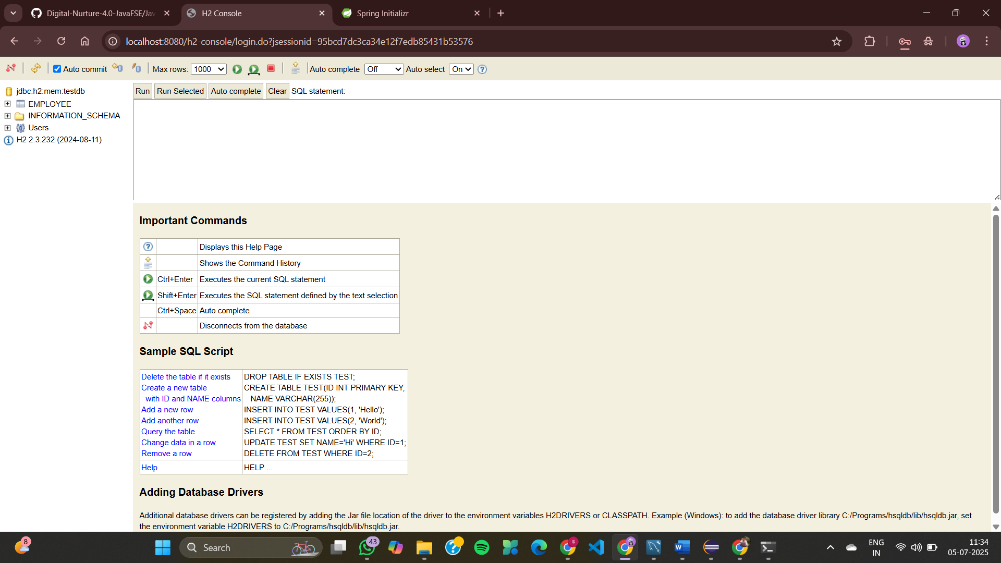
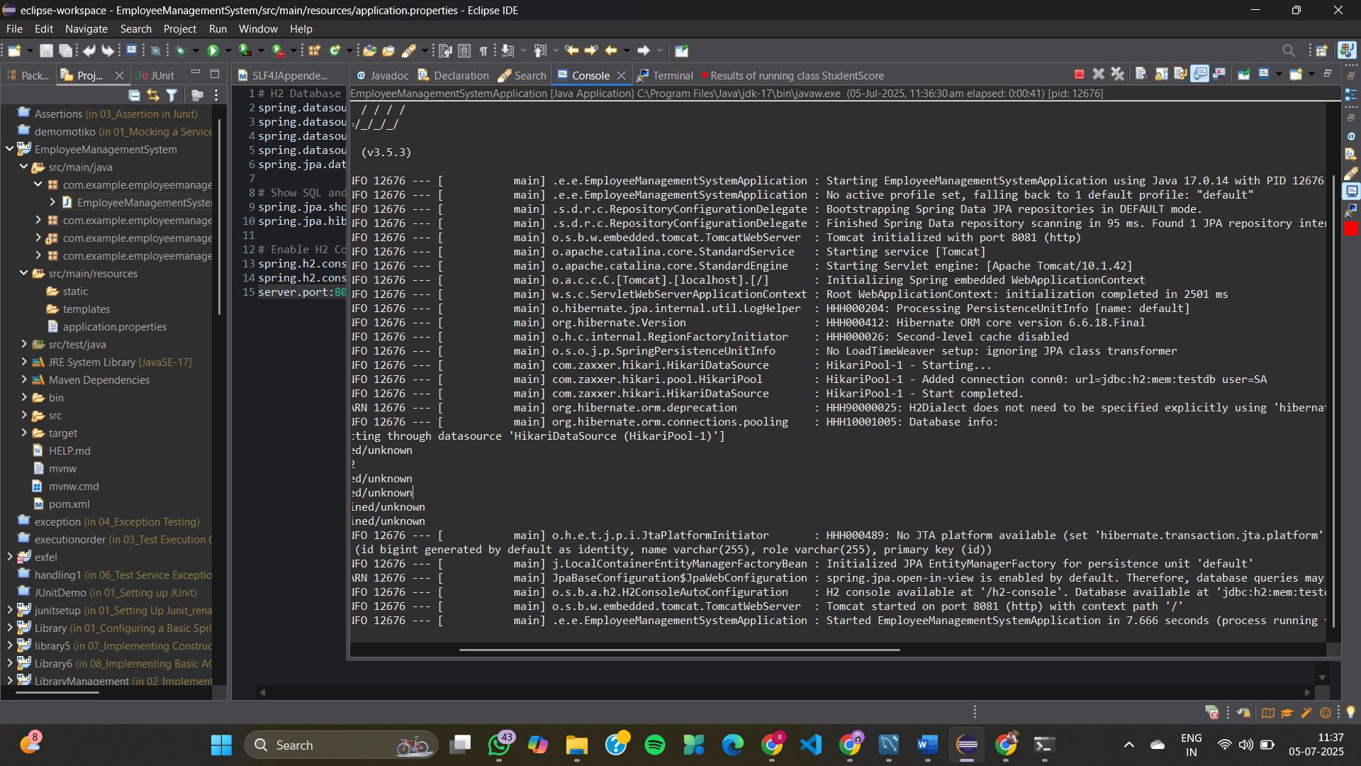

Exercise 2: Employee Management System - Creating Entities
Department.java
package com.example.demo.entity;

import jakarta.persistence.*;
import java.util.List;

@Entity
@Table(name = "departments")
public class Department {

@Id
@GeneratedValue(strategy = GenerationType.IDENTITY)
private Long id;

private String name;

@OneToMany(mappedBy = "department", cascade = CascadeType.ALL, orphanRemoval = true)
private List<Employee> employees;

public Department() {
}

public Long getId() {
return id;
}

public void setId(Long id) {
this.id = id;
}

public String getName() {
return name;
}

public void setName(String name) {
this.name = name;
}

public List<Employee> getEmployees() {
return employees;
}

public void setEmployees(List<Employee> employees) {
this.employees = employees;
}
}
Employee.java
package com.example.demo.entity;

import jakarta.persistence.*;

@Entity
@Table(name = "employees")
public class Employee {

@Id
@GeneratedValue(strategy = GenerationType.IDENTITY)
private Long id;

private String name;

private String email;

@ManyToOne
@JoinColumn(name = "department_id")
private Department department;

public Employee() {
}

// getters & setters

public Long getId() {
return id;
}

public void setId(Long id) {
this.id = id;
}

public String getName() {
return name;
}

public void setName(String name) {
this.name = name;
}

public String getEmail() {
return email;
}

public void setEmail(String email) {
this.email = email;
}

public Department getDepartment() {
return department;
}

public void setDepartment(Department department) {
this.department = department;
}
}
DepartmentRepository.java
package com.example.demo.repository;

import com.example.demo.entity.Department;
import org.springframework.data.jpa.repository.JpaRepository;

public interface DepartmentRepository extends JpaRepository<Department, Long> {
}
EmployeeRepository.java
package com.example.demo.repository;

import com.example.demo.entity.Employee;
import org.springframework.data.jpa.repository.JpaRepository;

public interface EmployeeRepository extends JpaRepository<Employee, Long> {
}

EmployeeManagementSystemApplication.java
package com.example.demo;

import com.example.demo.entity.Department;
import com.example.demo.entity.Employee;
import com.example.demo.repository.DepartmentRepository;
import org.springframework.boot.CommandLineRunner;
import org.springframework.boot.SpringApplication;
import org.springframework.boot.autoconfigure.SpringBootApplication;
import org.springframework.context.annotation.Bean;

import java.util.List;

@SpringBootApplication
public class EmployeeManagementSystemApplication {
public static void main(String[] args) {
SpringApplication.run(EmployeeManagementSystemApplication.class, args);
}

@Bean
public CommandLineRunner demo(DepartmentRepository deptRepo) {
return args -> {
Department dept = new Department();
dept.setName("IT");

Employee emp1 = new Employee();
emp1.setName("Alice");
emp1.setEmail("alice@example.com");
emp1.setDepartment(dept);

Employee emp2 = new Employee();
emp2.setName("Bob");
emp2.setEmail("bob@example.com");
emp2.setDepartment(dept);

dept.setEmployees(List.of(emp1, emp2));

deptRepo.save(dept);
};
}
}
application.properties
spring.datasource.url=jdbc:h2:mem:testdb
spring.datasource.driver-class-name=org.h2.Driver
spring.datasource.username=sa
spring.datasource.password=

spring.jpa.show-sql=true
spring.jpa.hibernate.ddl-auto=update

spring.h2.console.enabled=true
spring.h2.console.path=/h2-console
pom.xml
<project xmlns="http://maven.apache.org/POM/4.0.0"
xmlns:xsi="http://www.w3.org/2001/XMLSchema-instance"
xsi:schemaLocation="http://maven.apache.org/POM/4.0.0
https://maven.apache.org/xsd/maven-4.0.0.xsd">
<modelVersion>4.0.0</modelVersion>

<groupId>com.example</groupId>
<artifactId>employee-management-system</artifactId>
<version>0.0.1-SNAPSHOT</version>

<parent>
<groupId>org.springframework.boot</groupId>
<artifactId>spring-boot-starter-parent</artifactId>
<version>3.2.4</version>
</parent>

<dependencies>
<dependency>
<groupId>org.springframework.boot</groupId>
<artifactId>spring-boot-starter-data-jpa</artifactId>
</dependency>

<dependency>
<groupId>org.springframework.boot</groupId>
<artifactId>spring-boot-starter-web</artifactId>
</dependency>

<dependency>
<groupId>com.h2database</groupId>
<artifactId>h2</artifactId>
<scope>runtime</scope>
</dependency>

<dependency>
<groupId>org.projectlombok</groupId>
<artifactId>lombok</artifactId>
<optional>true</optional>
</dependency>
</dependencies>

<build>
<plugins>
<plugin>
<groupId>org.springframework.boot</groupId>
<artifactId>spring-boot-maven-plugin</artifactId>
</plugin>
</plugins>
</build>
</project>
OUTPUT
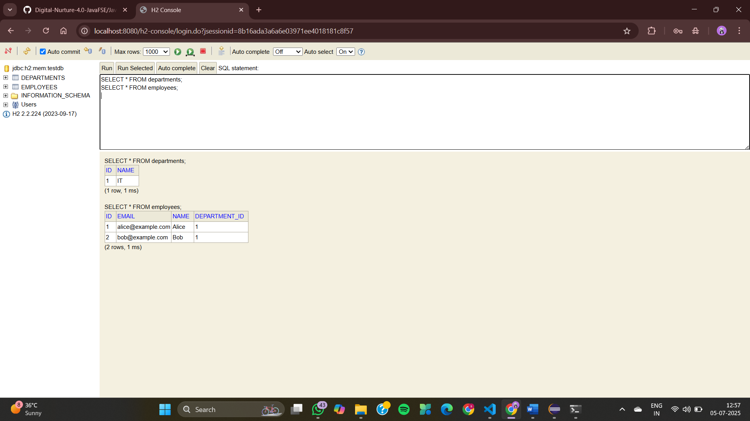
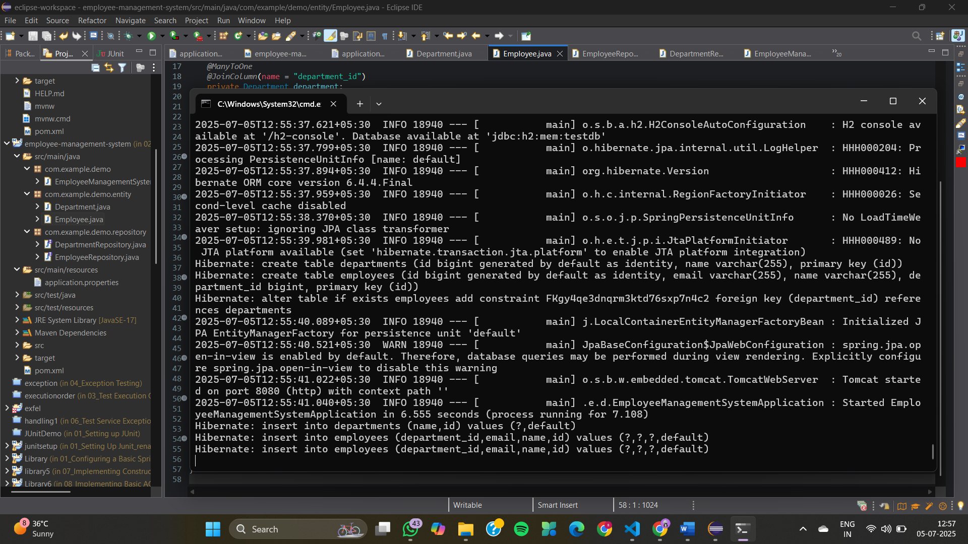
Exercise 3: Employee Management System - Creating Repositories
Department.java
package com.example.employee_management.entity;

import jakarta.persistence.*;

@Entity
public class Department {

@Id
@GeneratedValue(strategy = GenerationType.IDENTITY)
private Long id;

private String name;

public Department() {
}

public Department(String name) {
this.name = name;
}

// Getter & Setter for id
public Long getId() {
return id;
}

public void setId(Long id) {
this.id = id;
}

// Getter & Setter for name
public String getName() {
return name;
}

public void setName(String name) {
this.name = name;
}

@Override
public String toString() {
return "Department{" +
"id=" + id +
", name='" + name + '\'' +
'}';
}
}
Employee.java
package com.example.employee_management.entity;

import jakarta.persistence.*;

@Entity
public class Employee {

@Id
@GeneratedValue(strategy = GenerationType.IDENTITY)
private Long id;

private String name;

private String email;

@ManyToOne
@JoinColumn(name = "department_id")
private Department department;

public Employee() {
}

public Employee(String name, String email, Department department) {
this.name = name;
this.email = email;
this.department = department;
}

// Getter & Setter for id
public Long getId() {
return id;
}

public void setId(Long id) {
this.id = id;
}

// Getter & Setter for name
public String getName() {
return name;
}

public void setName(String name) {
this.name = name;
}

// Getter & Setter for email
public String getEmail() {
return email;
}

public void setEmail(String email) {
this.email = email;
}

// Getter & Setter for department
public Department getDepartment() {
return department;
}

public void setDepartment(Department department) {
this.department = department;
}

@Override
public String toString() {
return "Employee{" +
"id=" + id +
", name='" + name + '\'' +
", email='" + email + '\'' +
", department=" + department +
'}';
}
}

DepartmentRepository.java

package com.example.employee_management.repository;

import com.example.employee_management.entity.Department;

import org.springframework.data.jpa.repository.JpaRepository;

public interface DepartmentRepository extends JpaRepository<Department, Long> {

Department findByName(String name);

}

EmployeeRepository.java

package com.example.employee_management.repository;

import com.example.employee_management.entity.Employee;

import org.springframework.data.jpa.repository.JpaRepository;

import java.util.List;

public interface EmployeeRepository extends JpaRepository<Employee, Long> {

Employee findByEmail(String email);

List<Employee> findByDepartment_Name(String name);

}

EmployeeManagementApplication.java

package com.example.employee_management;

import com.example.employee_management.entity.Department;

import com.example.employee_management.entity.Employee;

import com.example.employee_management.repository.DepartmentRepository;

import com.example.employee_management.repository.EmployeeRepository;

import org.springframework.boot.CommandLineRunner;

import org.springframework.boot.SpringApplication;

import org.springframework.boot.autoconfigure.SpringBootApplication;

import org.springframework.context.annotation.Bean;

@SpringBootApplication

public class EmployeeManagementApplication {

public static void main(String[] args) {

SpringApplication.run(EmployeeManagementApplication.class, args);

}

@Bean

CommandLineRunner runner(EmployeeRepository employeeRepo, DepartmentRepository deptRepo) {

return args -> {

Department it = new Department();

it.setName("IT");

deptRepo.save(it);

Employee emp1 = new Employee();

emp1.setName("John Doe");

emp1.setEmail("john@example.com");

emp1.setDepartment(it);

employeeRepo.save(emp1);

Employee emp2 = new Employee();

emp2.setName("Jane Smith");

emp2.setEmail("jane@example.com");

emp2.setDepartment(it);

employeeRepo.save(emp2);

System.out.println("\nAll Employees:");

employeeRepo.findAll().forEach(System.out::println);

System.out.println("\nEmployee by Email:");

System.out.println(employeeRepo.findByEmail("jane@example.com"));

System.out.println("\nEmployees by Department Name:");

employeeRepo.findByDepartment_Name("IT").forEach(System.out::println);

};

}

}

application.properties

spring.application.name=employee-management

# H2 In-Memory DB config

spring.datasource.url=jdbc:h2:mem:testdb

spring.datasource.driver-class-name=org.h2.Driver

spring.datasource.username=sa

spring.datasource.password=

# JPA config

spring.jpa.hibernate.ddl-auto=update

spring.jpa.show-sql=true

# H2 console

spring.h2.console.enabled=true

EmployeeManagementApplicationTests.java

package com.example.employee_management;

import org.junit.jupiter.api.Test;

import org.springframework.boot.test.context.SpringBootTest;

@SpringBootTest

class EmployeeManagementApplicationTests {

@Test

void contextLoads() {

}

}

pom.xml

<project xmlns="http://maven.apache.org/POM/4.0.0"

xmlns:xsi="http://www.w3.org/2001/XMLSchema-instance"

xsi:schemaLocation="http://maven.apache.org/POM/4.0.0

https://maven.apache.org/xsd/maven-4.0.0.xsd">

<modelVersion>4.0.0</modelVersion>

<groupId>com.example</groupId>

<artifactId>employee-management</artifactId>

<version>1.0.0</version>

<packaging>jar</packaging>

<name>Employee Management</name>

<parent>

<groupId>org.springframework.boot</groupId>

<artifactId>spring-boot-starter-parent</artifactId>

<version>3.3.0</version>

</parent>

<dependencies>

<!-- Spring Boot Starter Data JPA -->

<dependency>

<groupId>org.springframework.boot</groupId>

<artifactId>spring-boot-starter-data-jpa</artifactId>

</dependency>

<!-- H2 Database -->

<dependency>

<groupId>com.h2database</groupId>

<artifactId>h2</artifactId>

<scope>runtime</scope>

</dependency>

<!-- Lombok -->

<dependency>

<groupId>org.projectlombok</groupId>

<artifactId>lombok</artifactId>

<optional>true</optional>

</dependency>

<!-- Spring Boot Starter -->

<dependency>

<groupId>org.springframework.boot</groupId>

<artifactId>spring-boot-starter</artifactId>

</dependency>

<!-- Test (optional) -->

<dependency>

<groupId>org.springframework.boot</groupId>

<artifactId>spring-boot-starter-test</artifactId>

<scope>test</scope>

</dependency>

</dependencies>

<build>

<plugins>

<plugin>

<groupId>org.springframework.boot</groupId>

<artifactId>spring-boot-maven-plugin</artifactId>

</plugin>

</plugins>

</build>

</project>

OUTPUT

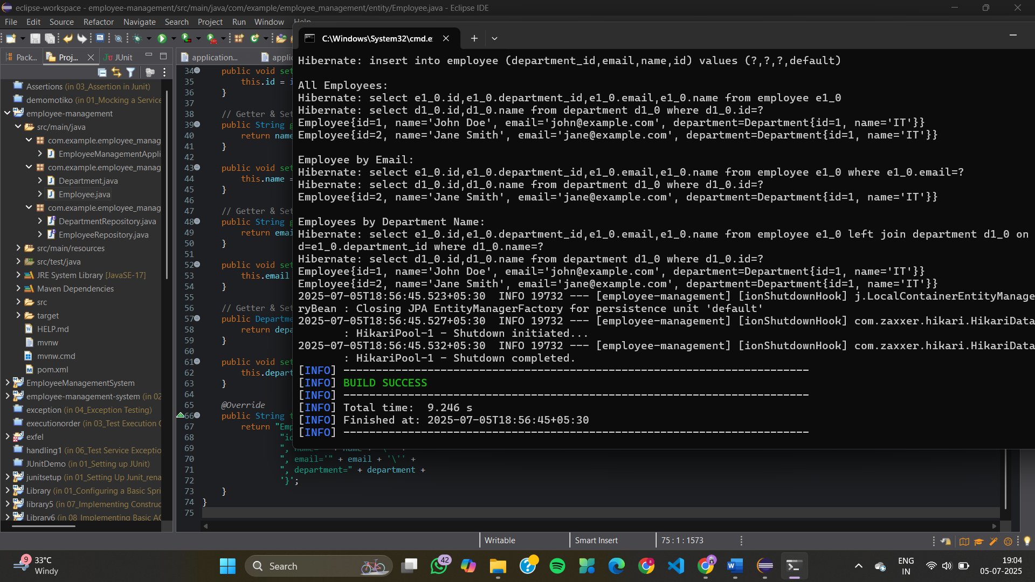

Exercise 4: Employee Management System - Implementing CRUD Operations
DepartmentController.java
package com.example.employee_management.controller;

import com.example.employee_management.entity.Department;
import com.example.employee_management.repository.DepartmentRepository;
import org.springframework.web.bind.annotation.*;

import java.util.List;

@RestController
@RequestMapping("/departments")
public class DepartmentController {

private final DepartmentRepository deptRepo;

public DepartmentController(DepartmentRepository deptRepo) {
this.deptRepo = deptRepo;
}

@GetMapping
public List<Department> getAll() {
return deptRepo.findAll();
}

@GetMapping("/{id}")
public Department getById(@PathVariable Long id) {
return deptRepo.findById(id).orElseThrow();
}

@PostMapping
public Department create(@RequestBody Department dept) {
return deptRepo.save(dept);
}

@PutMapping("/{id}")
public Department update(@PathVariable Long id, @RequestBody Department updatedDept) {
Department dept = deptRepo.findById(id).orElseThrow();
dept.setName(updatedDept.getName());
return deptRepo.save(dept);
}

@DeleteMapping("/{id}")
public void delete(@PathVariable Long id) {
deptRepo.deleteById(id);
}
}
EmployeeController.java
package com.example.employee_management.controller;

import com.example.employee_management.entity.Employee;
import com.example.employee_management.repository.EmployeeRepository;
import com.example.employee_management.repository.DepartmentRepository;

import org.springframework.web.bind.annotation.*;

import java.util.List;

@RestController
@RequestMapping("/employees")
public class EmployeeController {

private final EmployeeRepository empRepo;
private final DepartmentRepository deptRepo;

public EmployeeController(EmployeeRepository empRepo, DepartmentRepository deptRepo) {
this.empRepo = empRepo;
this.deptRepo = deptRepo;
}

@GetMapping
public List<Employee> getAll() {
return empRepo.findAll();
}

@GetMapping("/{id}")
public Employee getById(@PathVariable Long id) {
return empRepo.findById(id).orElseThrow();
}

@PostMapping
public Employee create(@RequestBody Employee emp) {
// Optional: make sure department exists
if (emp.getDepartment() != null) {
deptRepo.findById(emp.getDepartment().getId()).orElseThrow();
}
return empRepo.save(emp);
}

@PutMapping("/{id}")
public Employee update(@PathVariable Long id, @RequestBody Employee updatedEmp) {
Employee emp = empRepo.findById(id).orElseThrow();
emp.setName(updatedEmp.getName());
emp.setEmail(updatedEmp.getEmail());
if (updatedEmp.getDepartment() != null) {
deptRepo.findById(updatedEmp.getDepartment().getId()).orElseThrow();
emp.setDepartment(updatedEmp.getDepartment());
}
return empRepo.save(emp);
}

@DeleteMapping("/{id}")
public void delete(@PathVariable Long id) {
empRepo.deleteById(id);
}
}
Department.java
package com.example.employee_management.entity;

import jakarta.persistence.*;

@Entity
public class Department {
@Id
@GeneratedValue(strategy = GenerationType.IDENTITY)
private Long id;

private String name;

// 👉 Getter and Setter for id
public Long getId() {
return id;
}

public void setId(Long id) {
this.id = id;
}

// 👉 Getter and Setter for name
public String getName() {
return name;
}

public void setName(String name) {
this.name = name;
}
}
Employee.java
package com.example.employee_management.entity;

import jakarta.persistence.*;

@Entity
public class Employee {
@Id
@GeneratedValue(strategy = GenerationType.IDENTITY)
private Long id;

private String name;

private String email;

@ManyToOne
@JoinColumn(name = "department_id")
private Department department;

// 👉 Getter and Setter for id
public Long getId() {
return id;
}

public void setId(Long id) {
this.id = id;
}

// 👉 Getter and Setter for name
public String getName() {
return name;
}

public void setName(String name) {
this.name = name;
}

// 👉 Getter and Setter for email
public String getEmail() {
return email;
}

public void setEmail(String email) {
this.email = email;
}

// 👉 Getter and Setter for department
public Department getDepartment() {
return department;
}

public void setDepartment(Department department) {
this.department = department;
}
}
DepartmentRepository.java
package com.example.employee_management.repository;

import com.example.employee_management.entity.Department;
import org.springframework.data.jpa.repository.JpaRepository;

public interface DepartmentRepository extends JpaRepository<Department, Long> {
}
EmployeeRepository.java
package com.example.employee_management.repository;

import com.example.employee_management.entity.Employee;
import org.springframework.data.jpa.repository.JpaRepository;

public interface EmployeeRepository extends JpaRepository<Employee, Long> {
}
EmployeeManagementApplication.java
package com.example.employee_management;

import org.springframework.boot.SpringApplication;
import org.springframework.boot.autoconfigure.SpringBootApplication;

@SpringBootApplication
public class EmployeeManagementApplication {

public static void main(String[] args) {
SpringApplication.run(EmployeeManagementApplication.class, args);
}

}
application.properties
spring.application.name=employee-management
# H2 In-Memory DB config
spring.datasource.url=jdbc:h2:mem:testdb
spring.datasource.driver-class-name=org.h2.Driver
spring.datasource.username=sa
spring.datasource.password=

# JPA config
spring.jpa.hibernate.ddl-auto=update
spring.jpa.show-sql=true

# H2 console
spring.h2.console.enabled=true
EmployeeManagementApplicationTests.java
package com.example.employee_management;

import org.junit.jupiter.api.Test;
import org.springframework.boot.test.context.SpringBootTest;

@SpringBootTest
class EmployeeManagementApplicationTests {

@Test
void contextLoads() {
}

}
pom.xml
<project xmlns="http://maven.apache.org/POM/4.0.0"
xmlns:xsi="http://www.w3.org/2001/XMLSchema-instance"
xsi:schemaLocation="http://maven.apache.org/POM/4.0.0
https://maven.apache.org/xsd/maven-4.0.0.xsd">

<modelVersion>4.0.0</modelVersion>

<groupId>com.example</groupId>
<artifactId>employee-management</artifactId>
<version>1.0.0</version>
<packaging>jar</packaging>

<name>Employee Management</name>

<parent>
<groupId>org.springframework.boot</groupId>
<artifactId>spring-boot-starter-parent</artifactId>
<version>3.3.0</version>
</parent>

<dependencies>
<!-- Spring Boot Starter Web (IMPORTANT!) -->
<dependency>
<groupId>org.springframework.boot</groupId>
<artifactId>spring-boot-starter-web</artifactId>
</dependency>

<!-- Spring Boot Starter Data JPA -->
<dependency>
<groupId>org.springframework.boot</groupId>
<artifactId>spring-boot-starter-data-jpa</artifactId>
</dependency>

<!-- H2 Database -->
<dependency>
<groupId>com.h2database</groupId>
<artifactId>h2</artifactId>
<scope>runtime</scope>
</dependency>

<!-- Lombok -->
<dependency>
<groupId>org.projectlombok</groupId>
<artifactId>lombok</artifactId>
<optional>true</optional>
</dependency>

<!-- Spring Boot Starter (optional, already included by web) -->
<dependency>
<groupId>org.springframework.boot</groupId>
<artifactId>spring-boot-starter</artifactId>
</dependency>

<!-- Test -->
<dependency>
<groupId>org.springframework.boot</groupId>
<artifactId>spring-boot-starter-test</artifactId>
<scope>test</scope>
</dependency>
</dependencies>

<build>
<plugins>
<plugin>
<groupId>org.springframework.boot</groupId>
<artifactId>spring-boot-maven-plugin</artifactId>
</plugin>
</plugins>
</build>

</project>

OUTPUT
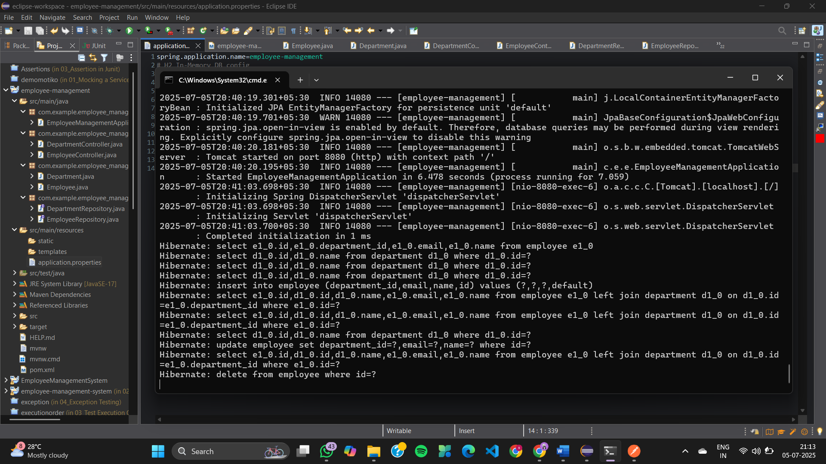
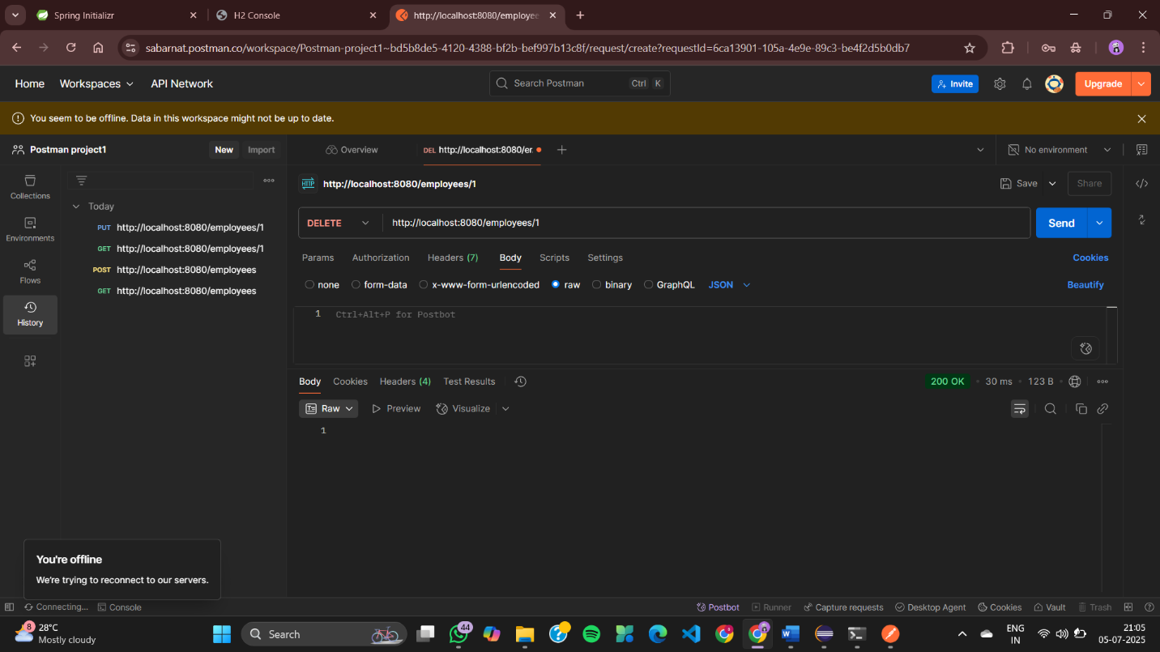
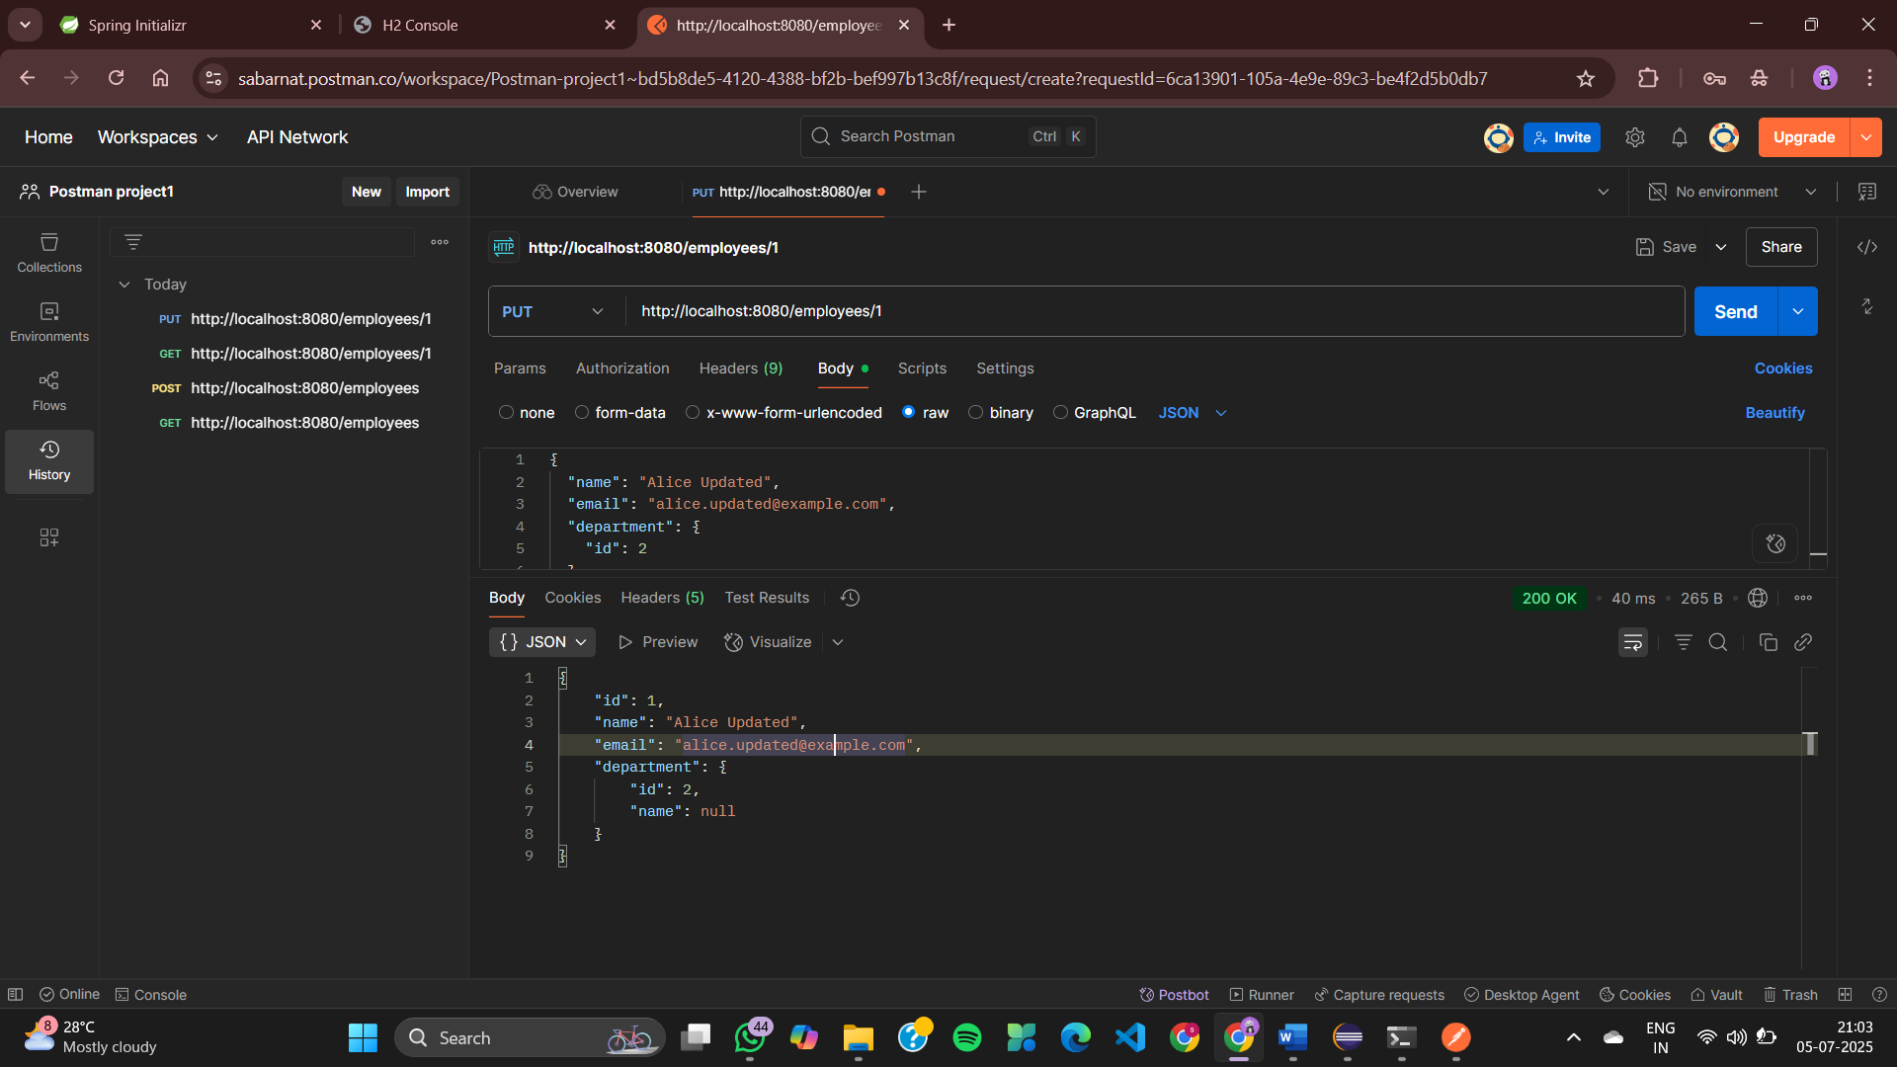
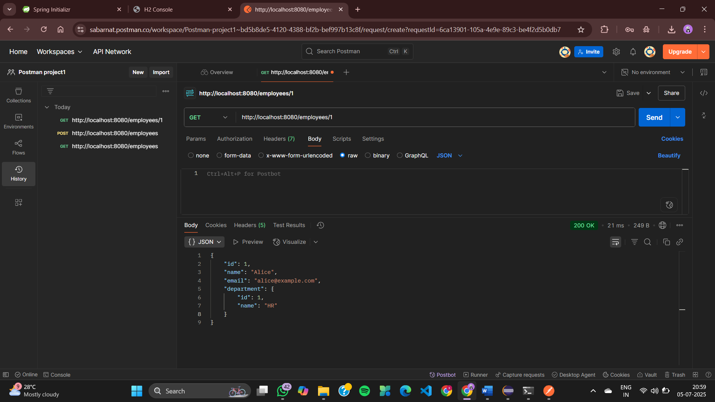

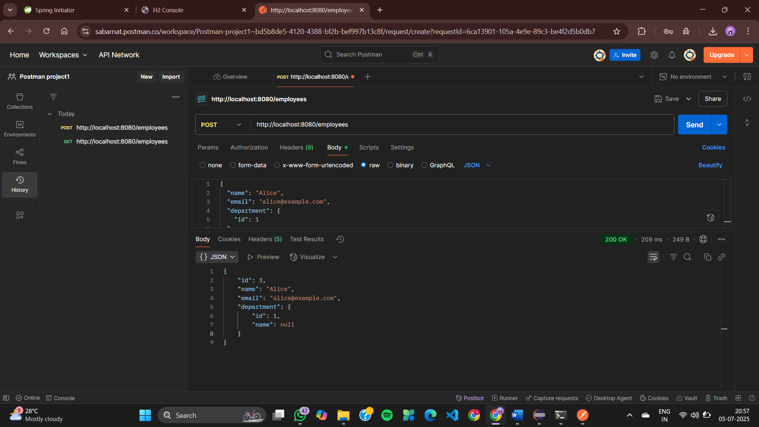
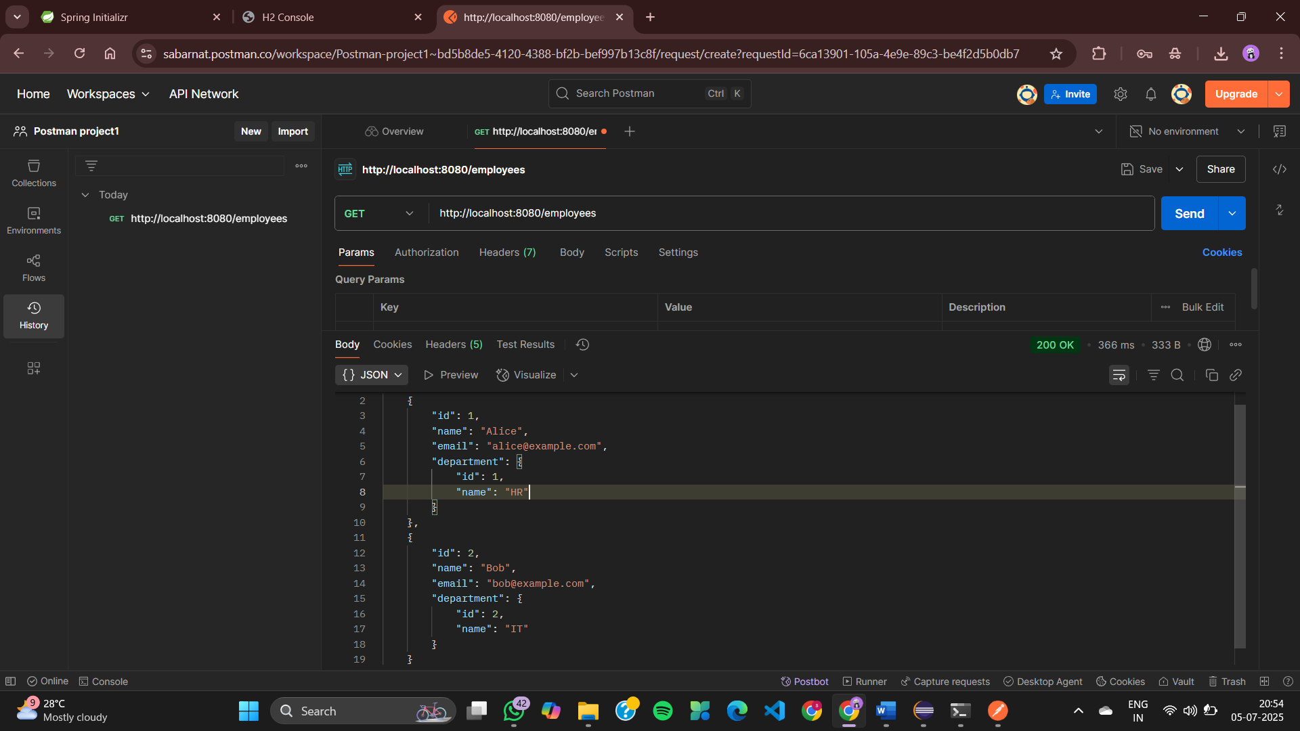
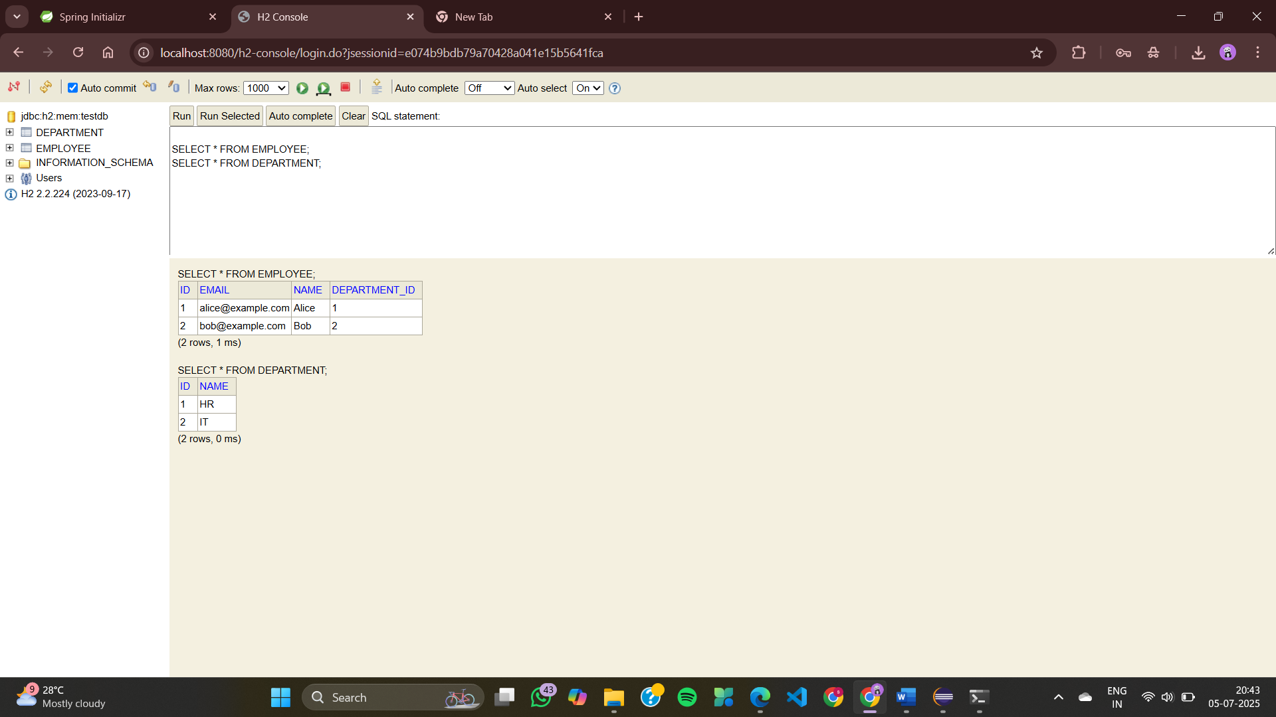
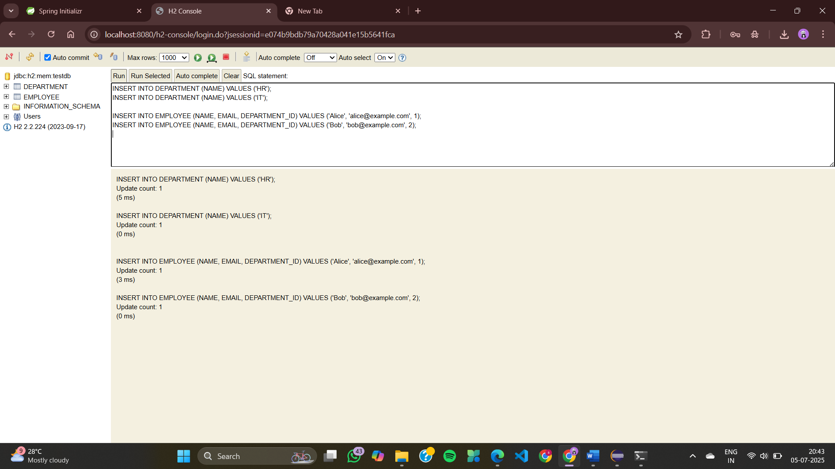
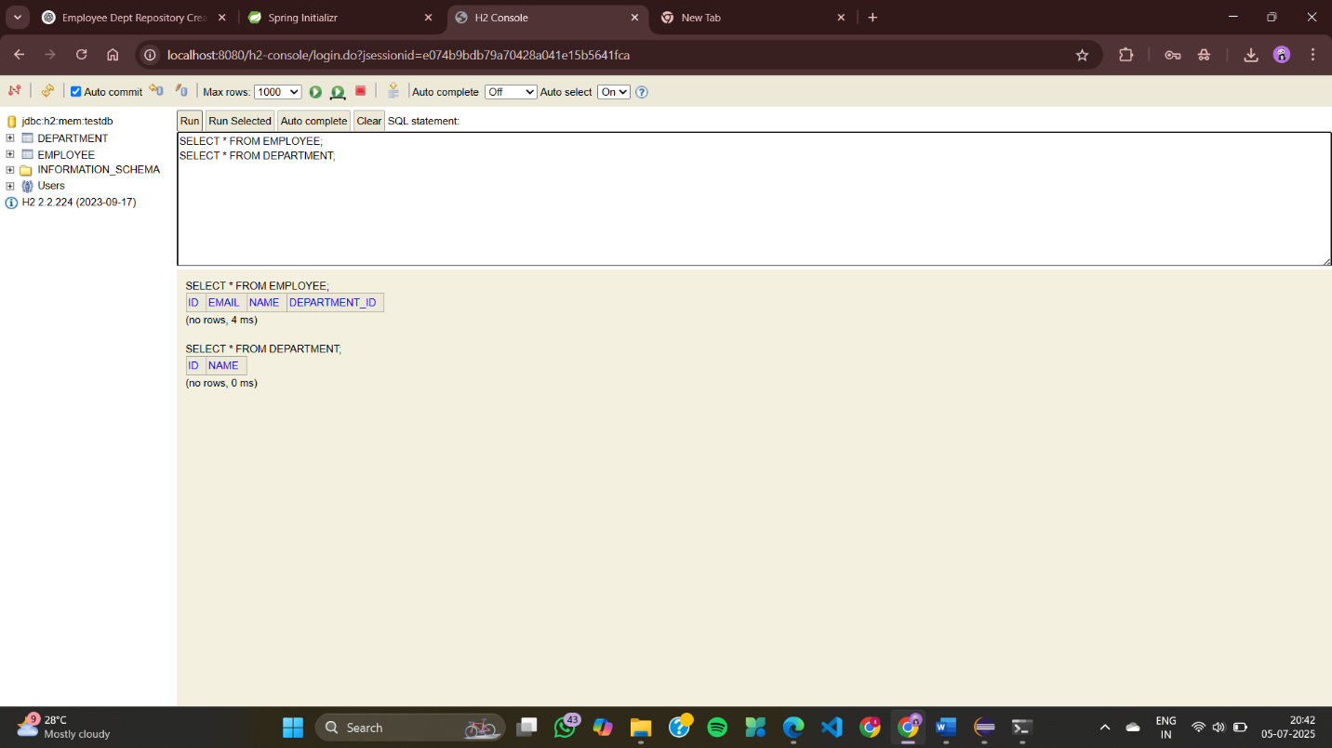
Exercise 5: Employee Management System - Defining Query Methods
DepartmentController.java
package com.example.employee_management.controller;

import com.example.employee_management.entity.Department;
import com.example.employee_management.repository.DepartmentRepository;
import org.springframework.web.bind.annotation.*;

import java.util.List;

@RestController
@RequestMapping("/departments")
public class DepartmentController {

private final DepartmentRepository deptRepo;

public DepartmentController(DepartmentRepository deptRepo) {
this.deptRepo = deptRepo;
}

@GetMapping
public List<Department> getAll() {
return deptRepo.findAll();
}

@GetMapping("/{id}")
public Department getById(@PathVariable Long id) {
return deptRepo.findById(id).orElseThrow();
}

@PostMapping
public Department create(@RequestBody Department dept) {
return deptRepo.save(dept);
}

@PutMapping("/{id}")
public Department update(@PathVariable Long id, @RequestBody Department updatedDept) {
Department dept = deptRepo.findById(id).orElseThrow();
dept.setName(updatedDept.getName());
return deptRepo.save(dept);
}

@DeleteMapping("/{id}")
public void delete(@PathVariable Long id) {
deptRepo.deleteById(id);
}
}
EmployeeController.java
package com.example.employee_management.controller;

import com.example.employee_management.entity.Employee;
import com.example.employee_management.repository.EmployeeRepository;
import com.example.employee_management.repository.DepartmentRepository;

import org.springframework.web.bind.annotation.*;

import java.util.List;

@RestController
@RequestMapping("/employees")
public class EmployeeController {

private final EmployeeRepository empRepo;
private final DepartmentRepository deptRepo;

public EmployeeController(EmployeeRepository empRepo, DepartmentRepository deptRepo) {
this.empRepo = empRepo;
this.deptRepo = deptRepo;
}

@GetMapping("/department/{name}")
public List<Employee> getByDepartmentName(@PathVariable String name) {
return empRepo.findByDepartment_Name(name);
}

@GetMapping("/name/{namePart}")
public List<Employee> getByNameContaining(@PathVariable String namePart) {
return empRepo.findByNameContainingIgnoreCase(namePart);
}

@GetMapping("/email/{email}")
public Employee getByEmail(@PathVariable String email) {
return empRepo.findByEmail(email);
}

@GetMapping("/namedquery/department/{id}")
public List<Employee> getByDepartmentIdNamedQuery(@PathVariable Long id) {
return empRepo.findByDepartmentId(id);
}

// existing CRUD endpoints…
}
Department.java
package com.example.employee_management.entity;

import jakarta.persistence.*;

@Entity
public class Department {
@Id
@GeneratedValue(strategy = GenerationType.IDENTITY)
private Long id;

private String name;

// 👉 Getter and Setter for id
public Long getId() {
return id;
}

public void setId(Long id) {
this.id = id;
}

// 👉 Getter and Setter for name
public String getName() {
return name;
}

public void setName(String name) {
this.name = name;
}
}
Employee.java
package com.example.employee_management.entity;

import jakarta.persistence.*;

@NamedQueries({
@NamedQuery(
name = "Employee.findByDepartmentId",
query = "SELECT e FROM Employee e WHERE e.department.id = :deptId"
),
@NamedQuery(
name = "Employee.findAllOrderedByName",
query = "SELECT e FROM Employee e ORDER BY e.name ASC"
)
})
@Entity
public class Employee {
@Id
@GeneratedValue(strategy = GenerationType.IDENTITY)
private Long id;

private String name;

private String email;

@ManyToOne
@JoinColumn(name = "department_id")
private Department department;

// getters and setters…
public Long getId() {
return id;
}

public void setId(Long id) {
this.id = id;
}

public String getName() {
return name;
}

public void setName(String name) {
this.name = name;
}

public String getEmail() {
return email;
}

public void setEmail(String email) {
this.email = email;
}

public Department getDepartment() {
return department;
}

public void setDepartment(Department department) {
this.department = department;
}
}
DepartmentRepository.java
package com.example.employee_management.repository;

import com.example.employee_management.entity.Department;
import org.springframework.data.jpa.repository.JpaRepository;

public interface DepartmentRepository extends JpaRepository<Department, Long> {
}
EmployeeRepository.java
package com.example.employee_management.repository;

import com.example.employee_management.entity.Employee;
import org.springframework.data.jpa.repository.JpaRepository;
import org.springframework.data.jpa.repository.Query;
import org.springframework.data.repository.query.Param;

import java.util.List;

public interface EmployeeRepository extends JpaRepository<Employee, Long> {

// Derived Query: find employees by department name
List<Employee> findByDepartment_Name(String deptName);

// Derived Query: find employees with name containing string (case-insensitive)
List<Employee> findByNameContainingIgnoreCase(String name);

// @Query: find employee by email
@Query("SELECT e FROM Employee e WHERE e.email = :email")
Employee findByEmail(@Param("email") String email);

// @Query: find employees in department by deptName
@Query("SELECT e FROM Employee e WHERE e.department.name = ?1")
List<Employee> getEmployeesInDepartment(String deptName);

// Named Query: find by departmentId
@Query(name = "Employee.findByDepartmentId")
List<Employee> findByDepartmentId(@Param("deptId") Long deptId);
}
EmployeeManagementApplication.java
package com.example.employee_management;

import org.springframework.boot.SpringApplication;
import org.springframework.boot.autoconfigure.SpringBootApplication;

@SpringBootApplication
public class EmployeeManagementApplication {

public static void main(String[] args) {
SpringApplication.run(EmployeeManagementApplication.class, args);
}

}
application.properties
spring.application.name=employee-management
# H2 In-Memory DB config
spring.datasource.url=jdbc:h2:mem:testdb
spring.datasource.driver-class-name=org.h2.Driver
spring.datasource.username=sa
spring.datasource.password=

# JPA config
spring.jpa.hibernate.ddl-auto=update
spring.jpa.show-sql=true

# H2 console
spring.h2.console.enabled=true
EmployeeManagementApplicationTests.java
package com.example.employee_management;

import org.junit.jupiter.api.Test;
import org.springframework.boot.test.context.SpringBootTest;

@SpringBootTest
class EmployeeManagementApplicationTests {

@Test
void contextLoads() {
}

}
OUTPUT
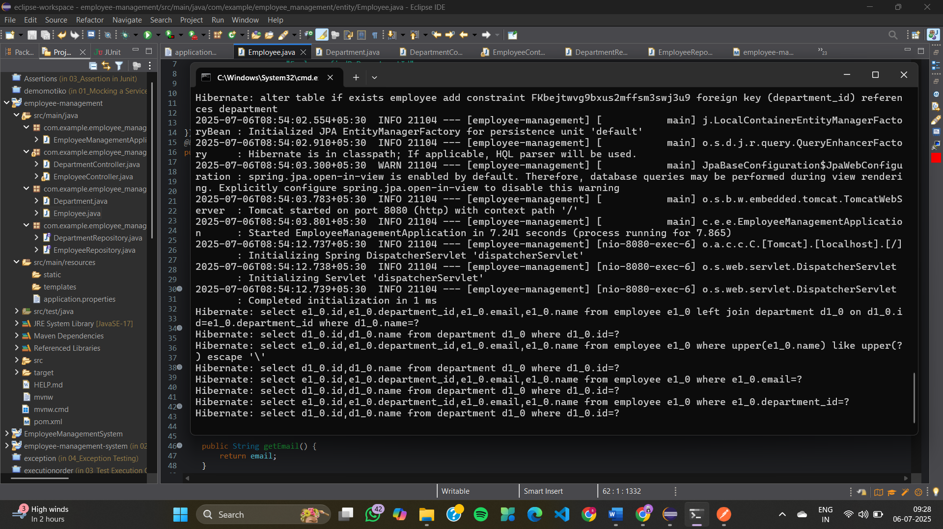
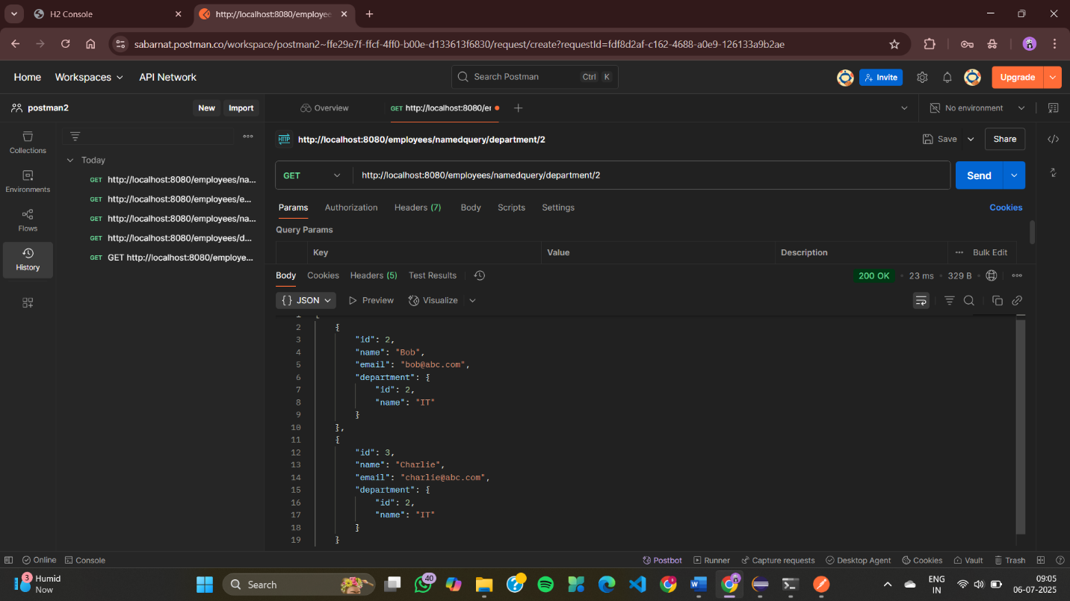
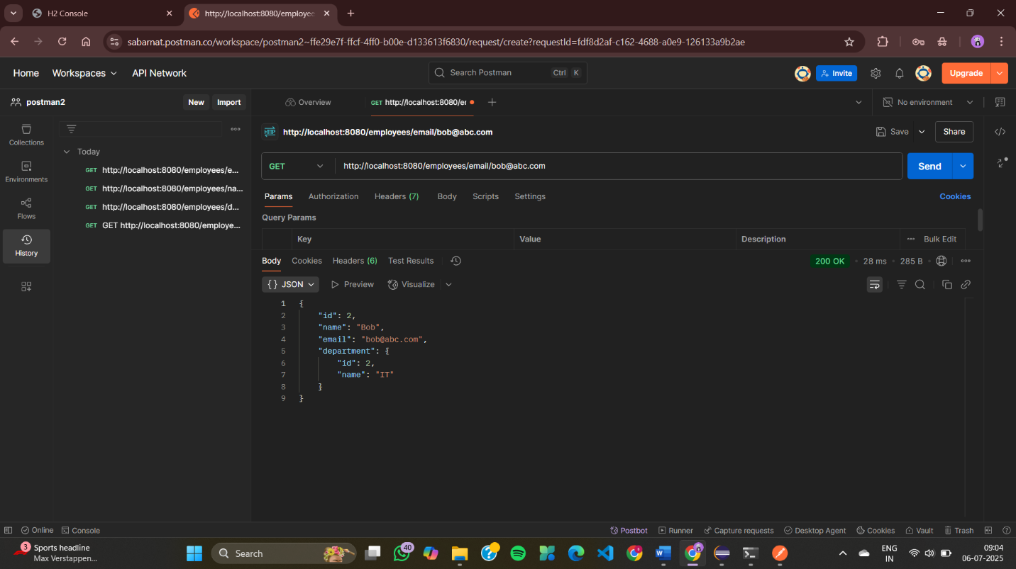
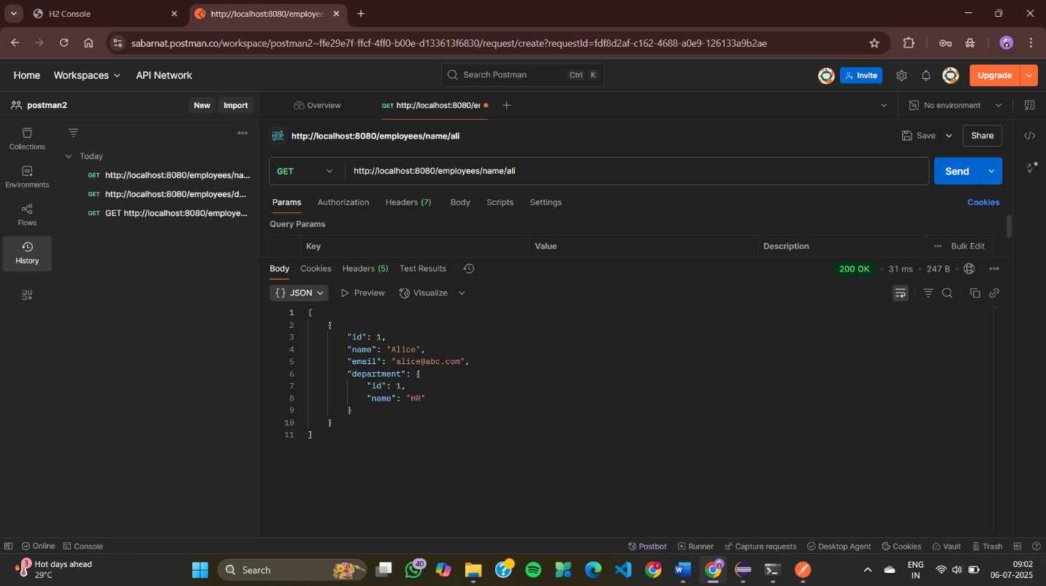
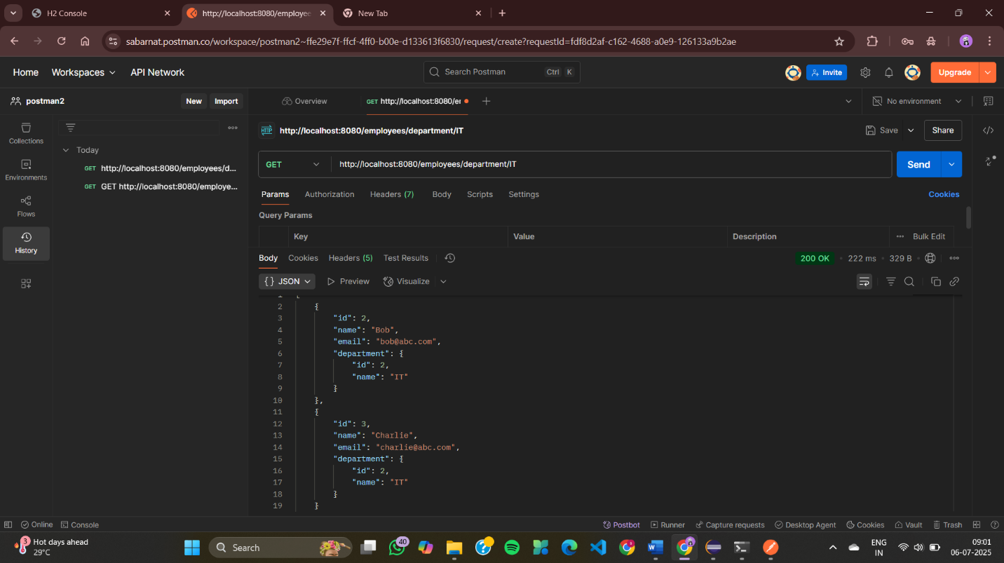
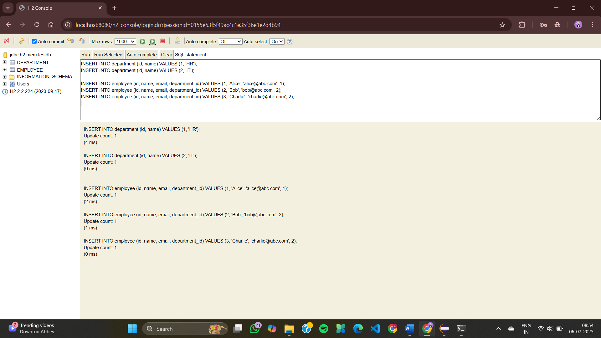

Exercise 6: Employee Management System - Implementing Pagination and Sorting
DepartmentController.java
package com.example.employee_management.controller;

import com.example.employee_management.entity.Department;
import com.example.employee_management.repository.DepartmentRepository;
import org.springframework.web.bind.annotation.*;

import java.util.List;

@RestController
@RequestMapping("/departments")
public class DepartmentController {

private final DepartmentRepository deptRepo;

public DepartmentController(DepartmentRepository deptRepo) {
this.deptRepo = deptRepo;
}

@GetMapping
public List<Department> getAll() {
return deptRepo.findAll();
}

@GetMapping("/{id}")
public Department getById(@PathVariable Long id) {
return deptRepo.findById(id).orElseThrow();
}

@PostMapping
public Department create(@RequestBody Department dept) {
return deptRepo.save(dept);
}

@PutMapping("/{id}")
public Department update(@PathVariable Long id, @RequestBody Department updatedDept) {
Department dept = deptRepo.findById(id).orElseThrow();
dept.setName(updatedDept.getName());
return deptRepo.save(dept);
}

@DeleteMapping("/{id}")
public void delete(@PathVariable Long id) {
deptRepo.deleteById(id);
}
}
EmployeeController.java
package com.example.employee_management.controller;

import com.example.employee_management.entity.Employee;
import com.example.employee_management.repository.EmployeeRepository;
import com.example.employee_management.repository.DepartmentRepository;

import org.springframework.data.domain.*;
import org.springframework.web.bind.annotation.*;

import java.util.List;

@RestController
@RequestMapping("/employees")
public class EmployeeController {

private final EmployeeRepository empRepo;
private final DepartmentRepository deptRepo;

public EmployeeController(EmployeeRepository empRepo, DepartmentRepository deptRepo) {
this.empRepo = empRepo;
this.deptRepo = deptRepo;
}

@GetMapping
public List<Employee> getAll() {
return empRepo.findAll();
}

@GetMapping("/{id}")
public Employee getById(@PathVariable Long id) {
return empRepo.findById(id).orElseThrow();
}

@PostMapping
public Employee create(@RequestBody Employee emp) {
if (emp.getDepartment() != null) {
deptRepo.findById(emp.getDepartment().getId()).orElseThrow();
}
return empRepo.save(emp);
}

@PutMapping("/{id}")
public Employee update(@PathVariable Long id, @RequestBody Employee updatedEmp) {
Employee emp = empRepo.findById(id).orElseThrow();
emp.setName(updatedEmp.getName());
emp.setEmail(updatedEmp.getEmail());
if (updatedEmp.getDepartment() != null) {
deptRepo.findById(updatedEmp.getDepartment().getId()).orElseThrow();
emp.setDepartment(updatedEmp.getDepartment());
}
return empRepo.save(emp);
}

@DeleteMapping("/{id}")
public void delete(@PathVariable Long id) {
empRepo.deleteById(id);
}

@GetMapping("/paginated")
public Page<Employee> getPaginated(
@RequestParam(defaultValue = "0") int page,
@RequestParam(defaultValue = "5") int size,
@RequestParam(defaultValue = "id") String sortBy,
@RequestParam(defaultValue = "asc") String direction) {

Pageable pageable = PageRequest.of(
page,
size,
direction.equalsIgnoreCase("asc") ?
Sort.by(sortBy).ascending() :
Sort.by(sortBy).descending()
);

return empRepo.findAll(pageable);
}
}
Department.java
package com.example.employee_management.entity;

import jakarta.persistence.*;

@Entity
public class Department {
@Id
@GeneratedValue(strategy = GenerationType.IDENTITY)
private Long id;

private String name;

public Long getId() { return id; }
public void setId(Long id) { this.id = id; }

public String getName() { return name; }
public void setName(String name) { this.name = name; }
}
Employee.java
package com.example.employee_management.entity;

import jakarta.persistence.*;

@Entity
public class Employee {
@Id
@GeneratedValue(strategy = GenerationType.IDENTITY)
private Long id;

private String name;

private String email;

@ManyToOne
@JoinColumn(name = "department_id")
private Department department;

public Long getId() { return id; }
public void setId(Long id) { this.id = id; }

public String getName() { return name; }
public void setName(String name) { this.name = name; }

public String getEmail() { return email; }
public void setEmail(String email) { this.email = email; }

public Department getDepartment() { return department; }
public void setDepartment(Department department) { this.department = department; }
}
DepartmentRepository.java
package com.example.employee_management.repository;

import com.example.employee_management.entity.Department;
import org.springframework.data.jpa.repository.JpaRepository;

public interface DepartmentRepository extends JpaRepository<Department, Long> {
}
EmployeeRepository.java
package com.example.employee_management.repository;

import com.example.employee_management.entity.Employee;
import org.springframework.data.jpa.repository.JpaRepository;

public interface EmployeeRepository extends JpaRepository<Employee, Long> {
}
EmployeeManagementApplication.java
package com.example.employee_management;

import org.springframework.boot.SpringApplication;
import org.springframework.boot.autoconfigure.SpringBootApplication;

@SpringBootApplication
public class EmployeeManagementApplication {
public static void main(String[] args) {
SpringApplication.run(EmployeeManagementApplication.class, args);
}
}
application.properties
spring.application.name=employee-management

spring.datasource.url=jdbc:h2:mem:testdb
spring.datasource.driver-class-name=org.h2.Driver
spring.datasource.username=sa
spring.datasource.password=

spring.jpa.hibernate.ddl-auto=update
spring.jpa.show-sql=true

spring.h2.console.enabled=true
EmployeeManagementApplicationTests.java
package com.example.employee_management;

import org.junit.jupiter.api.Test;
import org.springframework.boot.test.context.SpringBootTest;

@SpringBootTest
class EmployeeManagementApplicationTests {

@Test
void contextLoads() {
}

}
OUTPUT
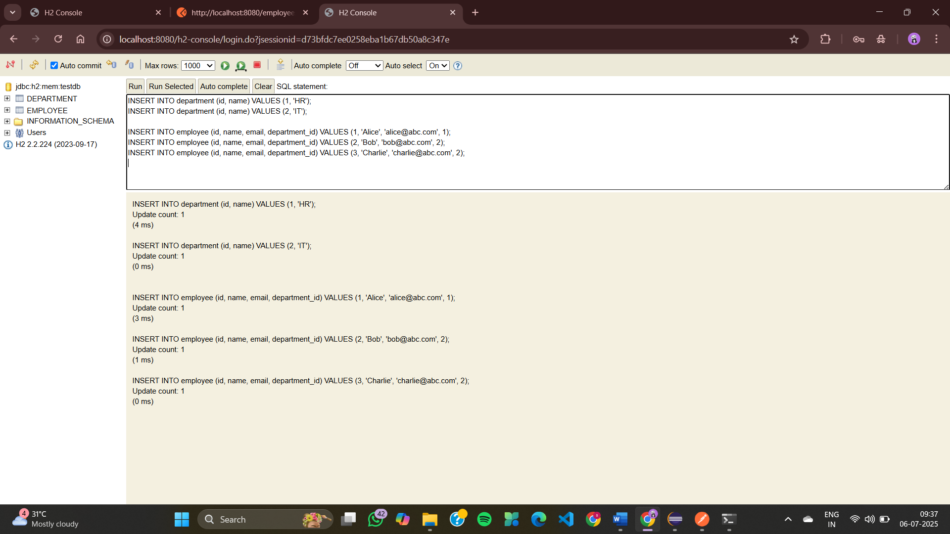
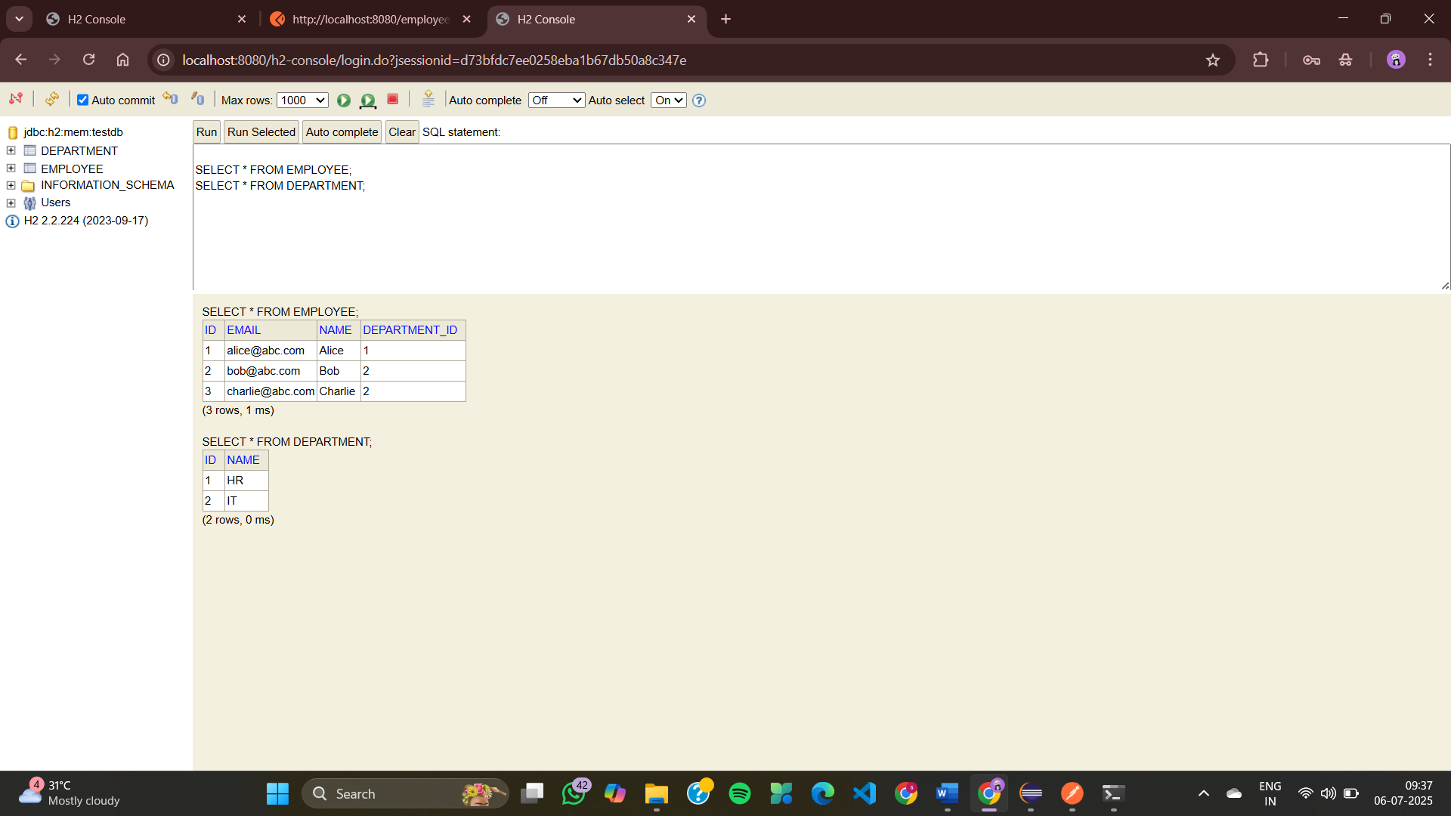
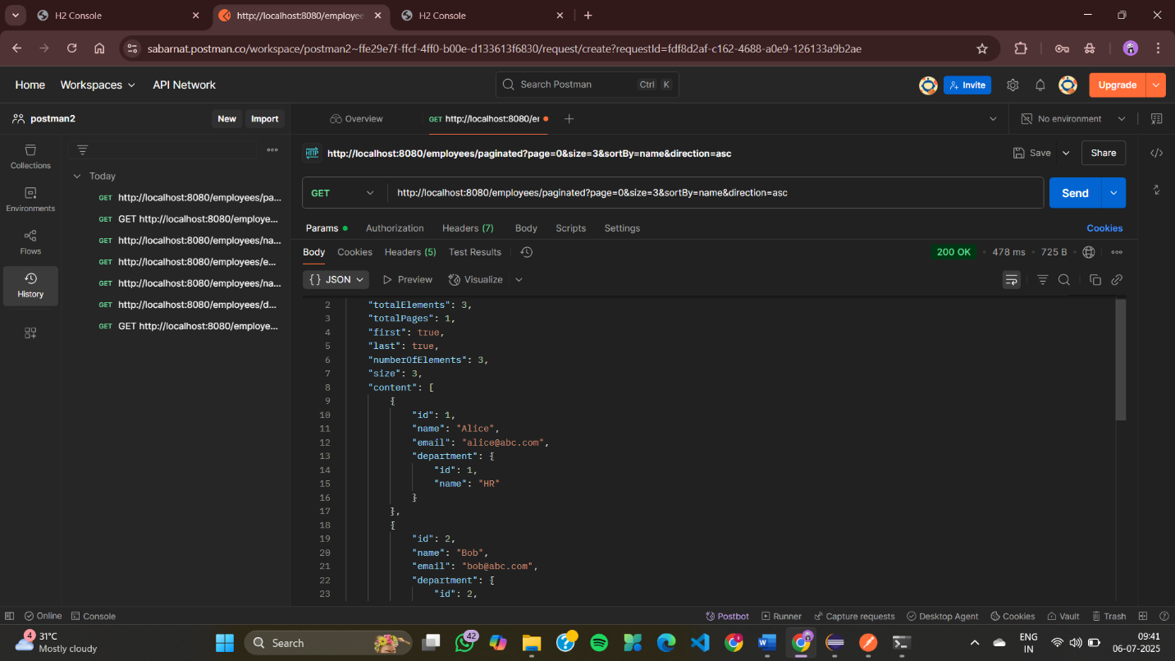
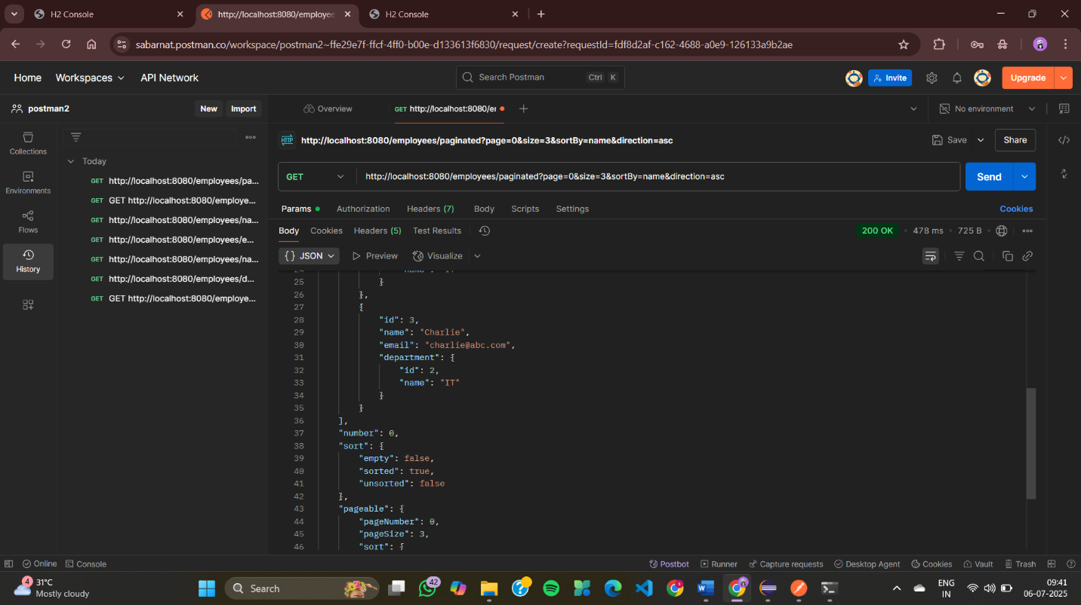
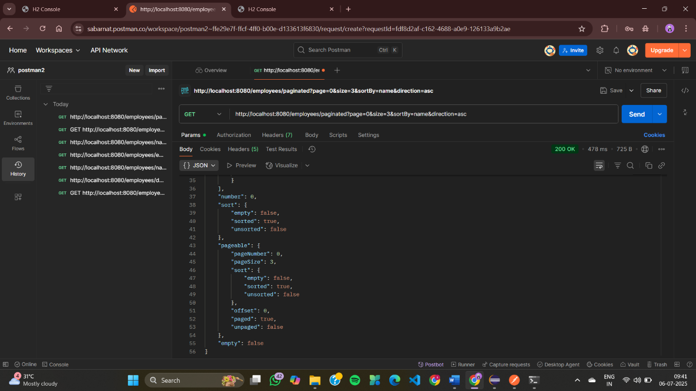
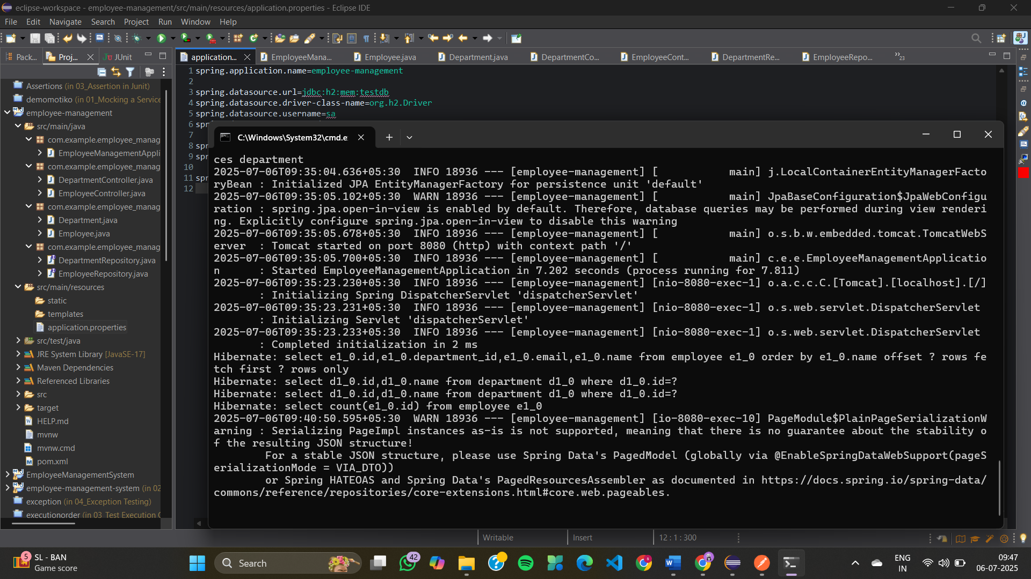

Exercise 7: Employee Management System - Enabling Entity Auditing
AuditorAwareImpl.java
package com.example.employee_management.config;

import org.springframework.context.annotation.Configuration;
import org.springframework.data.domain.AuditorAware;

import java.util.Optional;

@Configuration
public class AuditorAwareImpl implements AuditorAware<String> {
@Override
public Optional<String> getCurrentAuditor() {
// hardcoded for demo — change to actual user in real apps
return Optional.of("system-user");
}
}
DepartmentController.java
package com.example.employee_management.controller;

import com.example.employee_management.entity.Department;
import com.example.employee_management.repository.DepartmentRepository;
import org.springframework.web.bind.annotation.*;

import java.util.List;

@RestController
@RequestMapping("/departments")
public class DepartmentController {

private final DepartmentRepository deptRepo;

public DepartmentController(DepartmentRepository deptRepo) {
this.deptRepo = deptRepo;
}

@GetMapping
public List<Department> getAll() {
return deptRepo.findAll();
}

@GetMapping("/{id}")
public Department getById(@PathVariable Long id) {
return deptRepo.findById(id).orElseThrow();
}

@PostMapping
public Department create(@RequestBody Department dept) {
return deptRepo.save(dept);
}

@PutMapping("/{id}")
public Department update(@PathVariable Long id, @RequestBody Department updatedDept) {
Department dept = deptRepo.findById(id).orElseThrow();
dept.setName(updatedDept.getName());
return deptRepo.save(dept);
}

@DeleteMapping("/{id}")
public void delete(@PathVariable Long id) {
deptRepo.deleteById(id);
}
}
EmployeeController.java
package com.example.employee_management.controller;

import com.example.employee_management.entity.Employee;
import com.example.employee_management.repository.EmployeeRepository;
import com.example.employee_management.repository.DepartmentRepository;
import org.springframework.web.bind.annotation.*;

import java.util.List;

@RestController
@RequestMapping("/employees")
public class EmployeeController {

private final EmployeeRepository empRepo;
private final DepartmentRepository deptRepo;

public EmployeeController(EmployeeRepository empRepo, DepartmentRepository deptRepo) {
this.empRepo = empRepo;
this.deptRepo = deptRepo;
}

@GetMapping
public List<Employee> getAll() {
return empRepo.findAll();
}

@GetMapping("/{id}")
public Employee getById(@PathVariable Long id) {
return empRepo.findById(id).orElseThrow();
}

@PostMapping
public Employee create(@RequestBody Employee emp) {
if (emp.getDepartment() != null) {
deptRepo.findById(emp.getDepartment().getId()).orElseThrow();
}
return empRepo.save(emp);
}

@PutMapping("/{id}")
public Employee update(@PathVariable Long id, @RequestBody Employee updatedEmp) {
Employee emp = empRepo.findById(id).orElseThrow();
emp.setName(updatedEmp.getName());
emp.setEmail(updatedEmp.getEmail());
if (updatedEmp.getDepartment() != null) {
deptRepo.findById(updatedEmp.getDepartment().getId()).orElseThrow();
emp.setDepartment(updatedEmp.getDepartment());
}
return empRepo.save(emp);
}

@DeleteMapping("/{id}")
public void delete(@PathVariable Long id) {
empRepo.deleteById(id);
}
}
Department.java
package com.example.employee_management.entity;

import jakarta.persistence.*;
import jakarta.persistence.Id;

import org.springframework.data.annotation.*;
import org.springframework.data.jpa.domain.support.AuditingEntityListener;

import java.time.LocalDateTime;

@Entity
@EntityListeners(AuditingEntityListener.class)
public class Department {

@Id
@GeneratedValue(strategy = GenerationType.IDENTITY)
private Long id;

private String name;

@CreatedDate
@Column(updatable = false)
private LocalDateTime createdDate;

@LastModifiedDate
private LocalDateTime lastModifiedDate;

@CreatedBy
private String createdBy;

@LastModifiedBy
private String lastModifiedBy;

public Long getId() { return id; }
public void setId(Long id) { this.id = id; }

public String getName() { return name; }
public void setName(String name) { this.name = name; }

public LocalDateTime getCreatedDate() { return createdDate; }
public void setCreatedDate(LocalDateTime createdDate) { this.createdDate = createdDate; }

public LocalDateTime getLastModifiedDate() { return lastModifiedDate; }
public void setLastModifiedDate(LocalDateTime lastModifiedDate) { this.lastModifiedDate = lastModifiedDate; }

public String getCreatedBy() { return createdBy; }
public void setCreatedBy(String createdBy) { this.createdBy = createdBy; }

public String getLastModifiedBy() { return lastModifiedBy; }
public void setLastModifiedBy(String lastModifiedBy) { this.lastModifiedBy = lastModifiedBy; }
}
Employee.java
package com.example.employee_management.entity;

import jakarta.persistence.*;
import jakarta.persistence.Id;

import org.springframework.data.annotation.*;
import org.springframework.data.jpa.domain.support.AuditingEntityListener;

import java.time.LocalDateTime;

@Entity
@EntityListeners(AuditingEntityListener.class)
public class Employee {

@Id
@GeneratedValue(strategy = GenerationType.IDENTITY)
private Long id;

private String name;

private String email;

@ManyToOne
@JoinColumn(name = "department_id")
private Department department;

@CreatedDate
@Column(updatable = false)
private LocalDateTime createdDate;

@LastModifiedDate
private LocalDateTime lastModifiedDate;

@CreatedBy
private String createdBy;

@LastModifiedBy
private String lastModifiedBy;

public Long getId() { return id; }
public void setId(Long id) { this.id = id; }

public String getName() { return name; }
public void setName(String name) { this.name = name; }

public String getEmail() { return email; }
public void setEmail(String email) { this.email = email; }

public Department getDepartment() { return department; }
public void setDepartment(Department department) { this.department = department; }

public LocalDateTime getCreatedDate() { return createdDate; }
public void setCreatedDate(LocalDateTime createdDate) { this.createdDate = createdDate; }

public LocalDateTime getLastModifiedDate() { return lastModifiedDate; }
public void setLastModifiedDate(LocalDateTime lastModifiedDate) { this.lastModifiedDate = lastModifiedDate; }

public String getCreatedBy() { return createdBy; }
public void setCreatedBy(String createdBy) { this.createdBy = createdBy; }

public String getLastModifiedBy() { return lastModifiedBy; }
public void setLastModifiedBy(String lastModifiedBy) { this.lastModifiedBy = lastModifiedBy; }
}
DepartmentRepository.java
package com.example.employee_management.repository;

import com.example.employee_management.entity.Department;
import org.springframework.data.jpa.repository.JpaRepository;

public interface DepartmentRepository extends JpaRepository<Department, Long> {
}
EmployeeRepository.java
package com.example.employee_management.repository;

import com.example.employee_management.entity.Employee;
import org.springframework.data.jpa.repository.JpaRepository;

public interface EmployeeRepository extends JpaRepository<Employee, Long> {
}
EmployeeManagementApplication.java
package com.example.employee_management;

import org.springframework.boot.SpringApplication;
import org.springframework.boot.autoconfigure.SpringBootApplication;
import org.springframework.data.jpa.repository.config.EnableJpaAuditing;

@SpringBootApplication
@EnableJpaAuditing
public class EmployeeManagementApplication {
public static void main(String[] args) {
SpringApplication.run(EmployeeManagementApplication.class, args);
}
}
application.properties
spring.application.name=employee-management

spring.datasource.url=jdbc:h2:mem:testdb
spring.datasource.driver-class-name=org.h2.Driver
spring.datasource.username=sa
spring.datasource.password=

spring.jpa.hibernate.ddl-auto=update
spring.jpa.show-sql=true
spring.jpa.properties.hibernate.format_sql=true

spring.h2.console.enabled=true
EmployeeManagementApplicationTests.java
package com.example.employee_management;

import org.junit.jupiter.api.Test;
import org.springframework.boot.test.context.SpringBootTest;

@SpringBootTest
class EmployeeManagementApplicationTests {

@Test
void contextLoads() {
}

}

OUTPUT
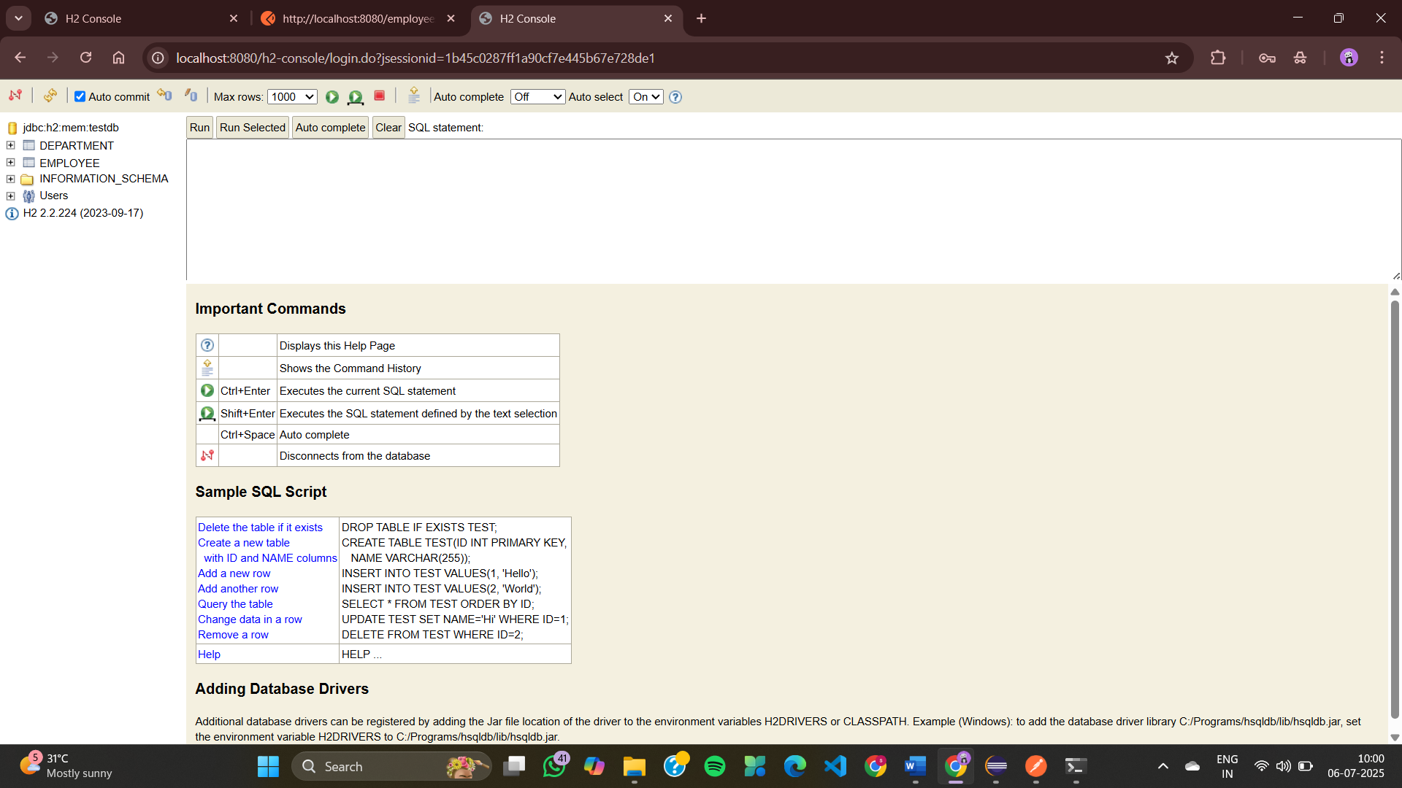
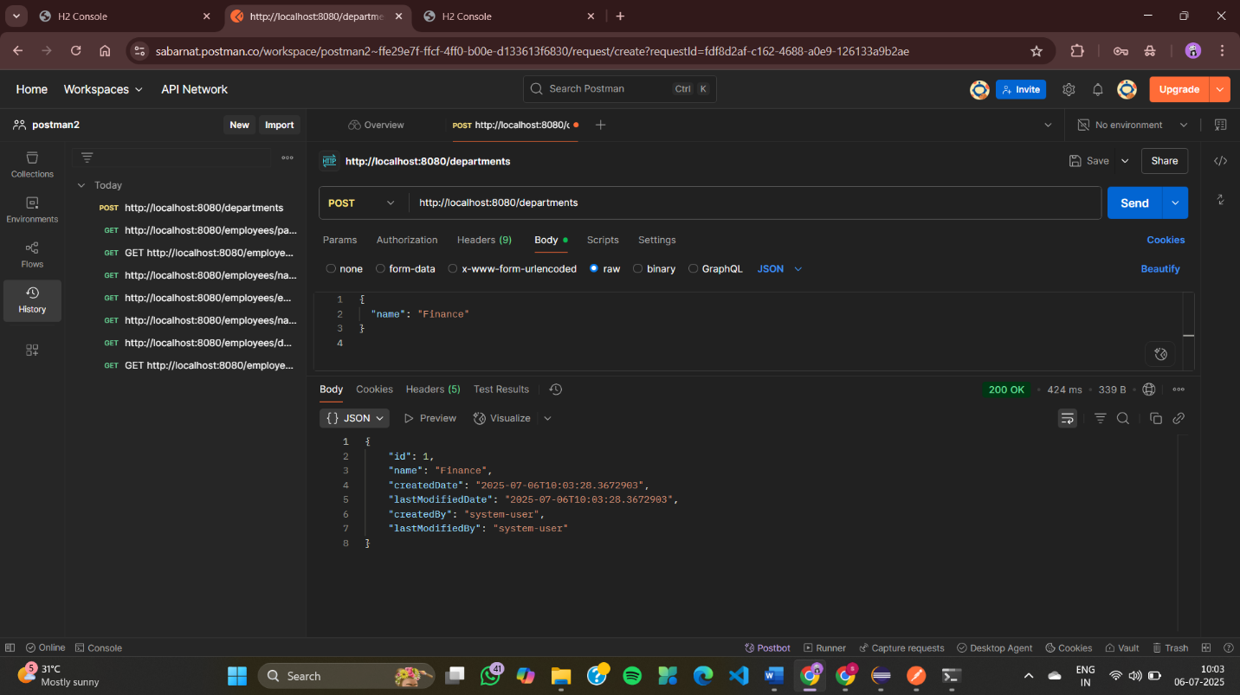
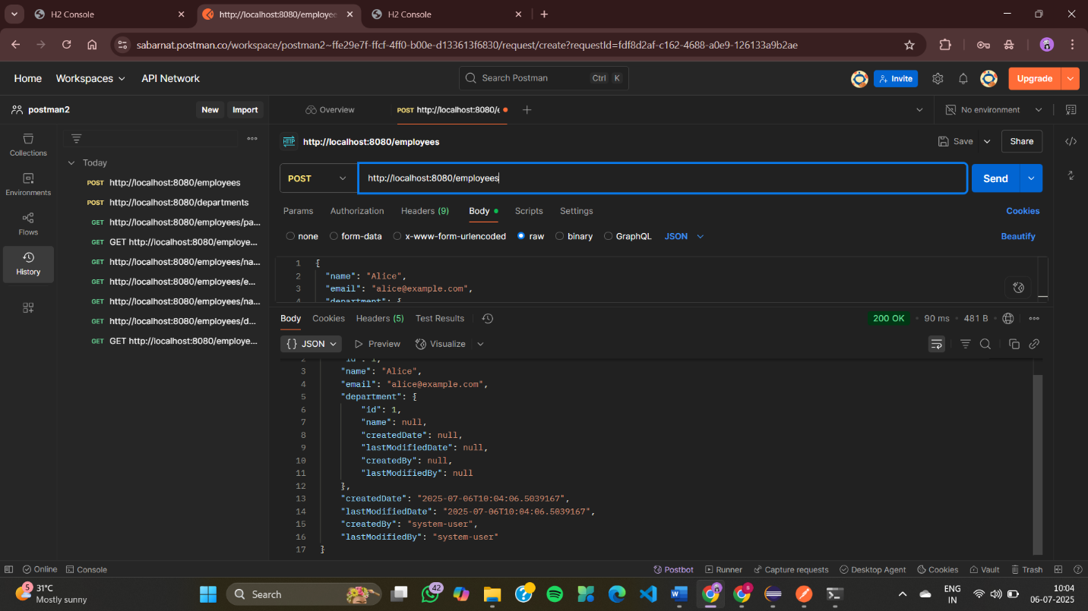
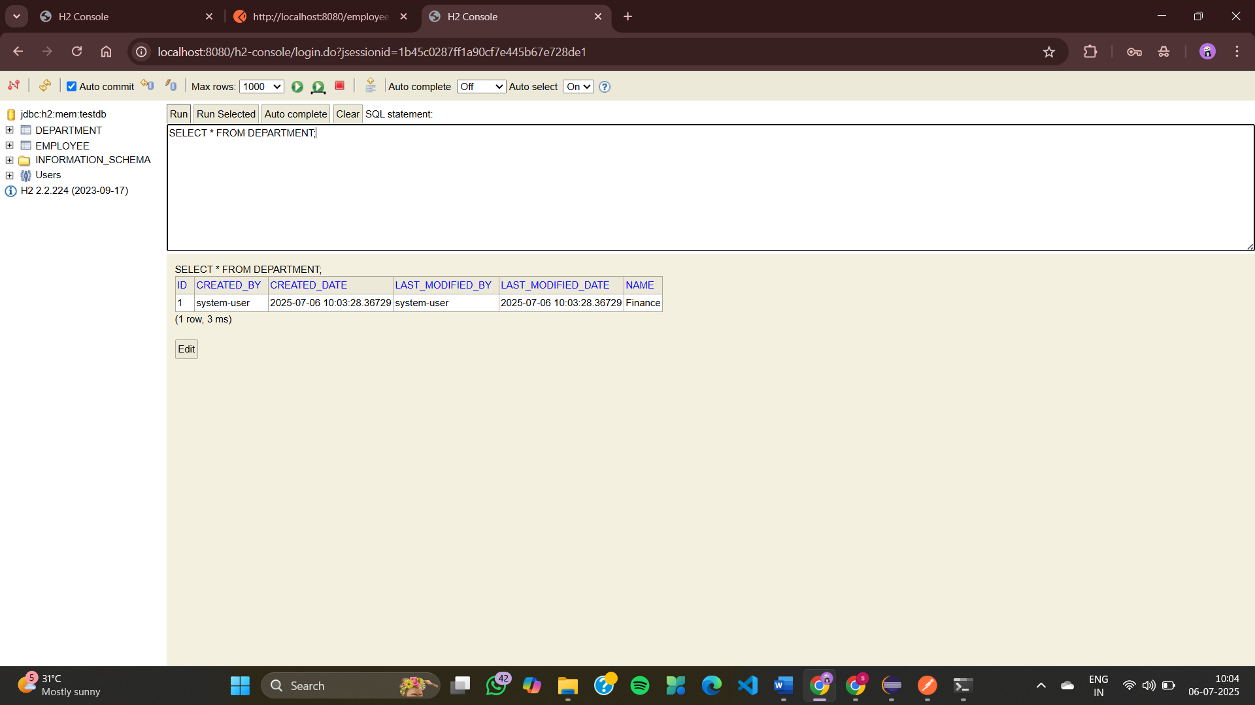
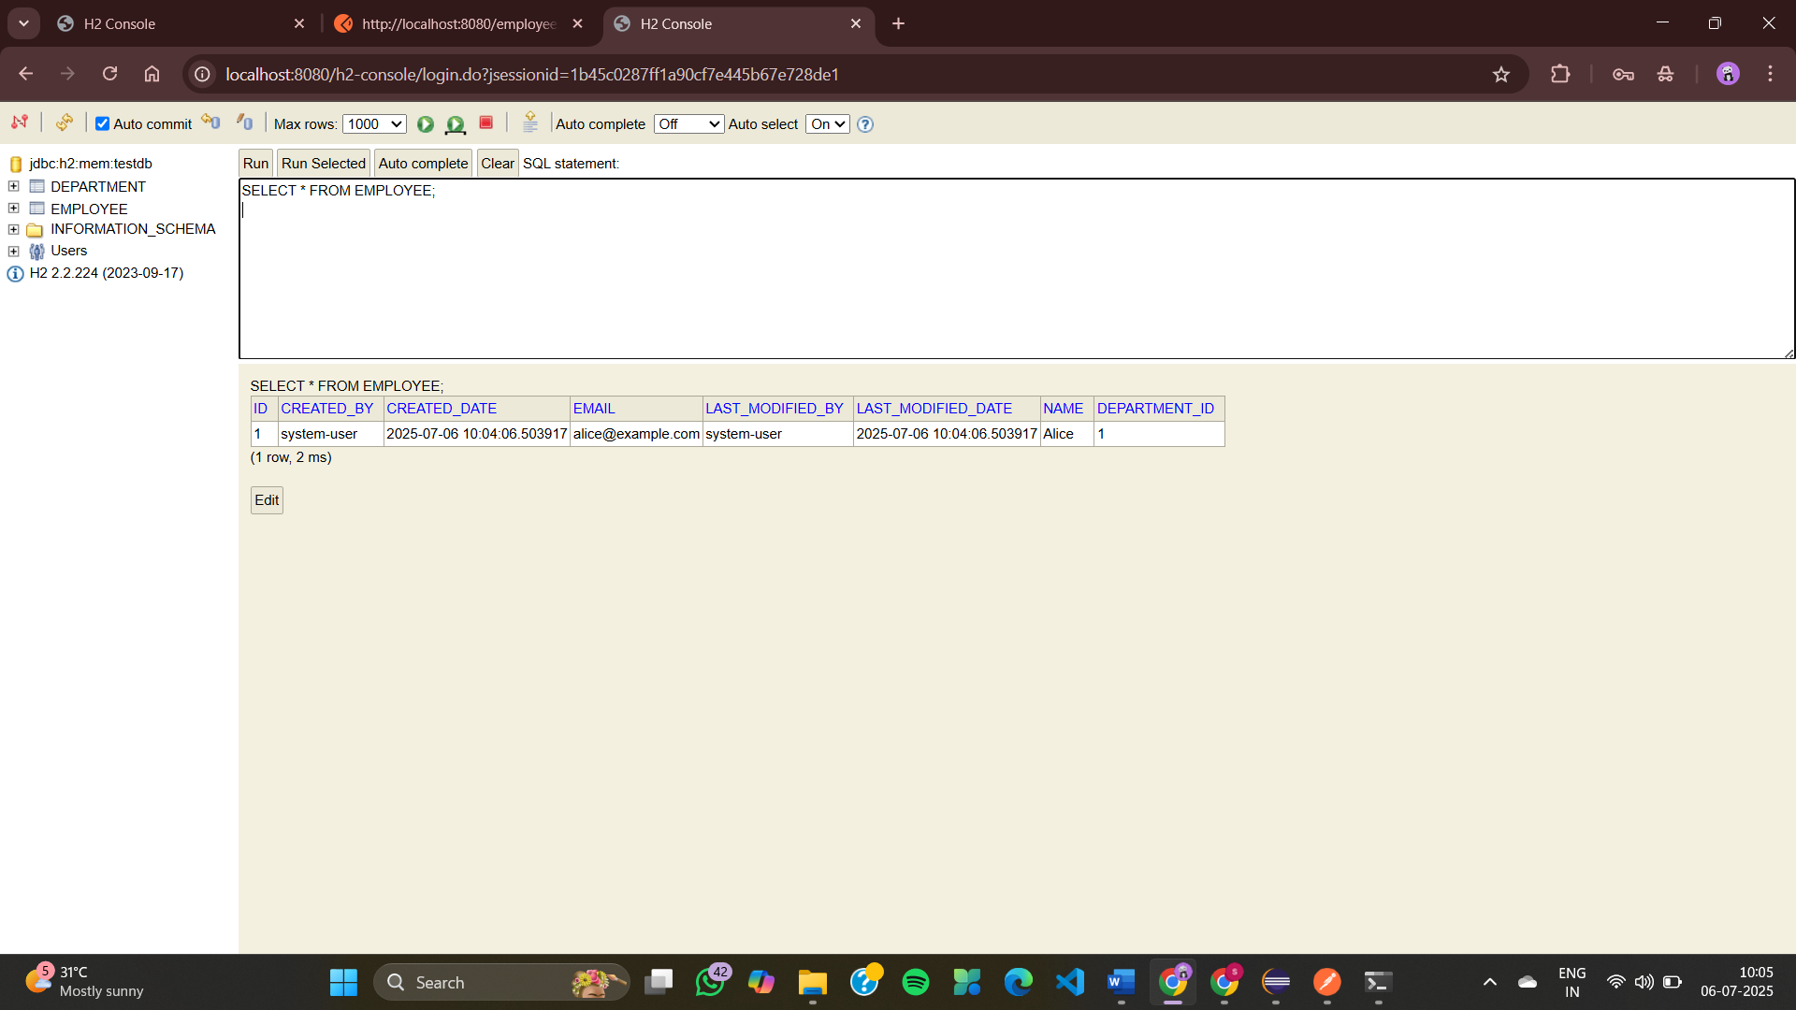
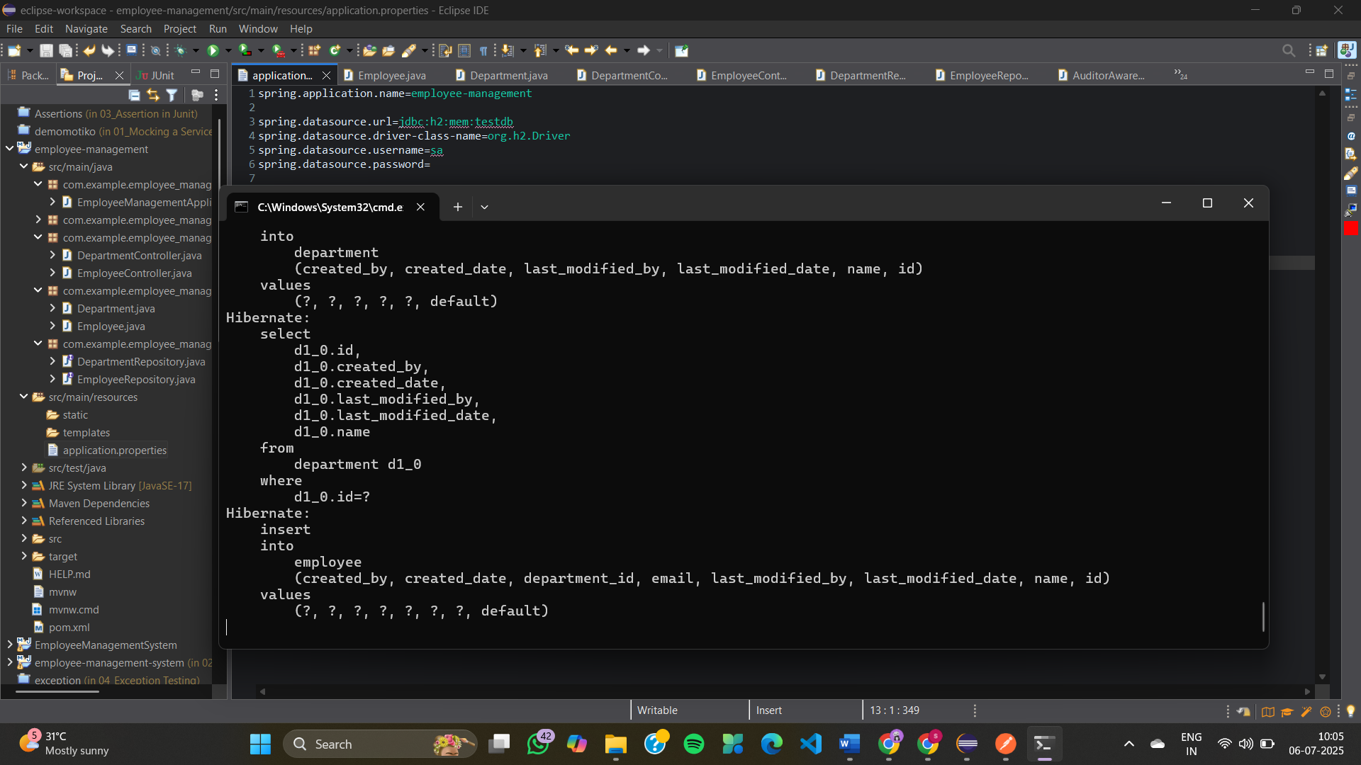

Exercise 8: Employee Management System - Creating Projections
AuditorAwareImpl.java
package com.example.employee_management.config;

import org.springframework.context.annotation.Configuration;
import org.springframework.data.domain.AuditorAware;

import java.util.Optional;

@Configuration
public class AuditorAwareImpl implements AuditorAware<String> {
@Override
public Optional<String> getCurrentAuditor() {
// hardcoded for demo — change to actual user in real apps
return Optional.of("system-user");
}
}
DepartmentController.java
package com.example.employee_management.controller;

import com.example.employee_management.entity.Department;
import com.example.employee_management.repository.DepartmentRepository;
import org.springframework.web.bind.annotation.*;

import java.util.List;

@RestController
@RequestMapping("/departments")
public class DepartmentController {

private final DepartmentRepository deptRepo;

public DepartmentController(DepartmentRepository deptRepo) {
this.deptRepo = deptRepo;
}

@GetMapping
public List<Department> getAll() {
return deptRepo.findAll();
}

@GetMapping("/{id}")
public Department getById(@PathVariable Long id) {
return deptRepo.findById(id).orElseThrow();
}

@PostMapping
public Department create(@RequestBody Department dept) {
return deptRepo.save(dept);
}

@PutMapping("/{id}")
public Department update(@PathVariable Long id, @RequestBody Department updatedDept) {
Department dept = deptRepo.findById(id).orElseThrow();
dept.setName(updatedDept.getName());
return deptRepo.save(dept);
}

@DeleteMapping("/{id}")
public void delete(@PathVariable Long id) {
deptRepo.deleteById(id);
}
}
EmployeeController.java
package com.example.employee_management.controller;

import com.example.employee_management.dto.EmployeeDTO;
import com.example.employee_management.entity.Employee;
import com.example.employee_management.projection.EmployeeNameEmailProjection;
import com.example.employee_management.repository.DepartmentRepository;
import com.example.employee_management.repository.EmployeeRepository;
import org.springframework.web.bind.annotation.*;

import java.util.List;

@RestController
@RequestMapping("/employees")
public class EmployeeController {

private final EmployeeRepository empRepo;
private final DepartmentRepository deptRepo;

public EmployeeController(EmployeeRepository empRepo, DepartmentRepository deptRepo) {
this.empRepo = empRepo;
this.deptRepo = deptRepo;
}

@GetMapping
public List<Employee> getAll() {
return empRepo.findAll();
}

@PostMapping
public Employee create(@RequestBody Employee emp) {
if (emp.getDepartment() != null) {
deptRepo.findById(emp.getDepartment().getId()).orElseThrow();
}
return empRepo.save(emp);
}

// Interface-based Projection
@GetMapping("/projection/interface/{deptId}")
public List<EmployeeNameEmailProjection> getEmployeeNamesEmailsByDept(@PathVariable Long deptId) {
return empRepo.findByDepartmentId(deptId);
}

// Class-based Projection
@GetMapping("/projection/class")
public List<EmployeeDTO> getEmployeeDTOs() {
return empRepo.fetchEmployeeWithDeptName();
}
}

EmployeeDTO.java
package com.example.employee_management.dto;

public class EmployeeDTO {
private String name;
private String departmentName;

public EmployeeDTO(String name, String departmentName) {
this.name = name;
this.departmentName = departmentName;
}

public String getName() { return name; }
public String getDepartmentName() { return departmentName; }
}
Department.java
package com.example.employee_management.entity;

import jakarta.persistence.*;

@Entity
public class Department {
@Id
@GeneratedValue(strategy = GenerationType.IDENTITY)
private Long id;

private String name;

public Long getId() { return id; }
public void setId(Long id) { this.id = id; }

public String getName() { return name; }
public void setName(String name) { this.name = name; }
}
Employee.java
package com.example.employee_management.entity;

import jakarta.persistence.*;

@Entity
public class Employee {
@Id
@GeneratedValue(strategy = GenerationType.IDENTITY)
private Long id;

private String name;

private String email;

@ManyToOne
@JoinColumn(name = "department_id")
private Department department;

public Long getId() { return id; }
public void setId(Long id) { this.id = id; }

public String getName() { return name; }
public void setName(String name) { this.name = name; }

public String getEmail() { return email; }
public void setEmail(String email) { this.email = email; }

public Department getDepartment() { return department; }
public void setDepartment(Department department) { this.department = department; }
}
EmployeeNameEmailProjection.java
package com.example.employee_management.projection;

public interface EmployeeNameEmailProjection {
String getName();
String getEmail();
}
DepartmentRepository.java
package com.example.employee_management.repository;

import com.example.employee_management.entity.Department;
import org.springframework.data.jpa.repository.JpaRepository;

public interface DepartmentRepository extends JpaRepository<Department, Long> {
}
EmployeeRepository.java
package com.example.employee_management.repository;

import com.example.employee_management.entity.Employee;
import com.example.employee_management.dto.EmployeeDTO;
import com.example.employee_management.projection.EmployeeNameEmailProjection;
import org.springframework.data.jpa.repository.JpaRepository;
import org.springframework.data.jpa.repository.Query;

import java.util.List;

public interface EmployeeRepository extends JpaRepository<Employee, Long> {
// Interface-based projection
List<EmployeeNameEmailProjection> findByDepartmentId(Long deptId);

// Class-based DTO projection
@Query("SELECT new com.example.employee_management.dto.EmployeeDTO(e.name, e.department.name) FROM Employee e")
List<EmployeeDTO> fetchEmployeeWithDeptName();
}
EmployeeManagementApplication.java
package com.example.employee_management;

import org.springframework.boot.SpringApplication;
import org.springframework.boot.autoconfigure.SpringBootApplication;

@SpringBootApplication
public class EmployeeManagementApplication {
public static void main(String[] args) {
SpringApplication.run(EmployeeManagementApplication.class, args);
}
}
application.properties
spring.datasource.url=jdbc:h2:mem:testdb
spring.datasource.driver-class-name=org.h2.Driver
spring.datasource.username=sa
spring.datasource.password=

spring.jpa.hibernate.ddl-auto=update
spring.jpa.show-sql=true

spring.h2.console.enabled=true
EmployeeManagementApplicationTests.java
package com.example.employee_management;

import org.junit.jupiter.api.Test;
import org.springframework.boot.test.context.SpringBootTest;

@SpringBootTest
class EmployeeManagementApplicationTests {

@Test
void contextLoads() {
}
}
OUTPUT
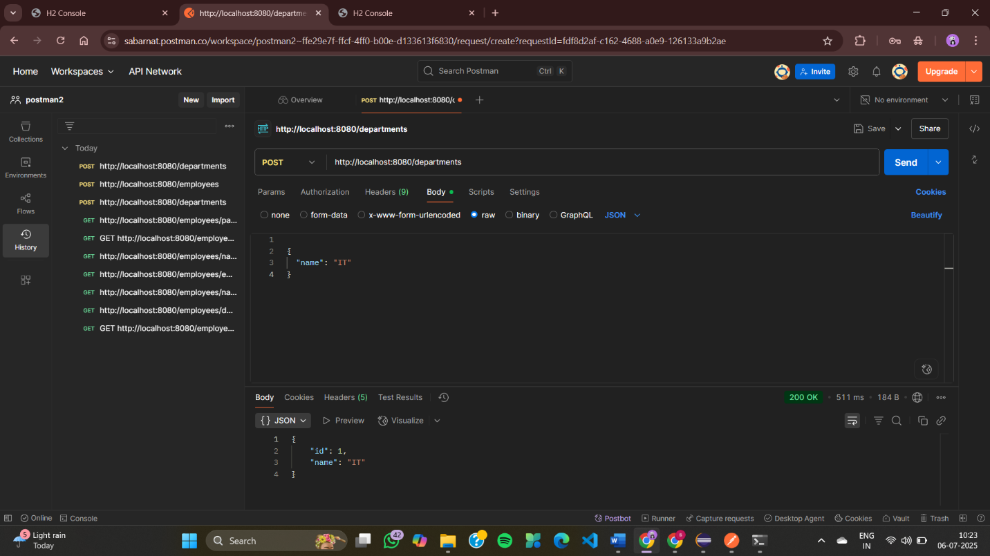
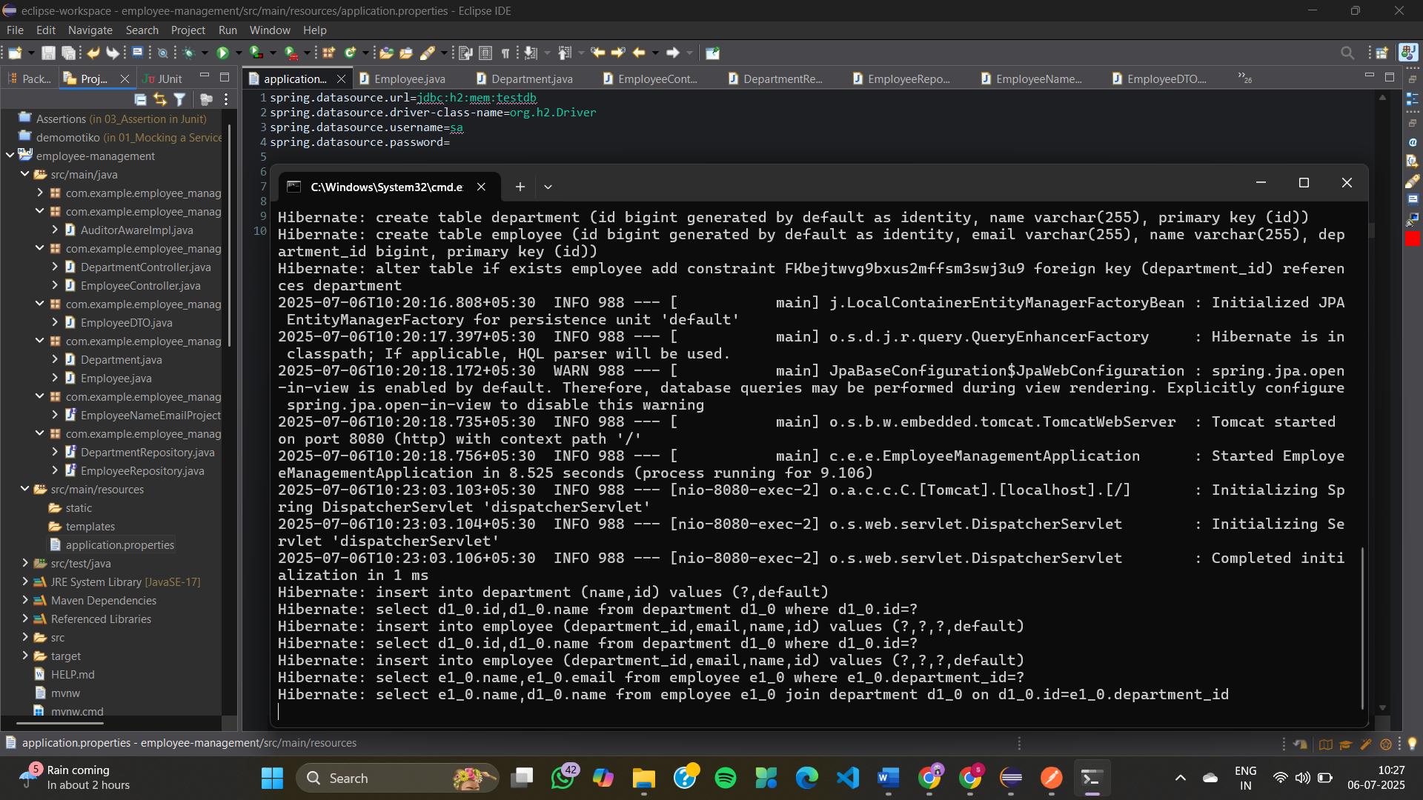
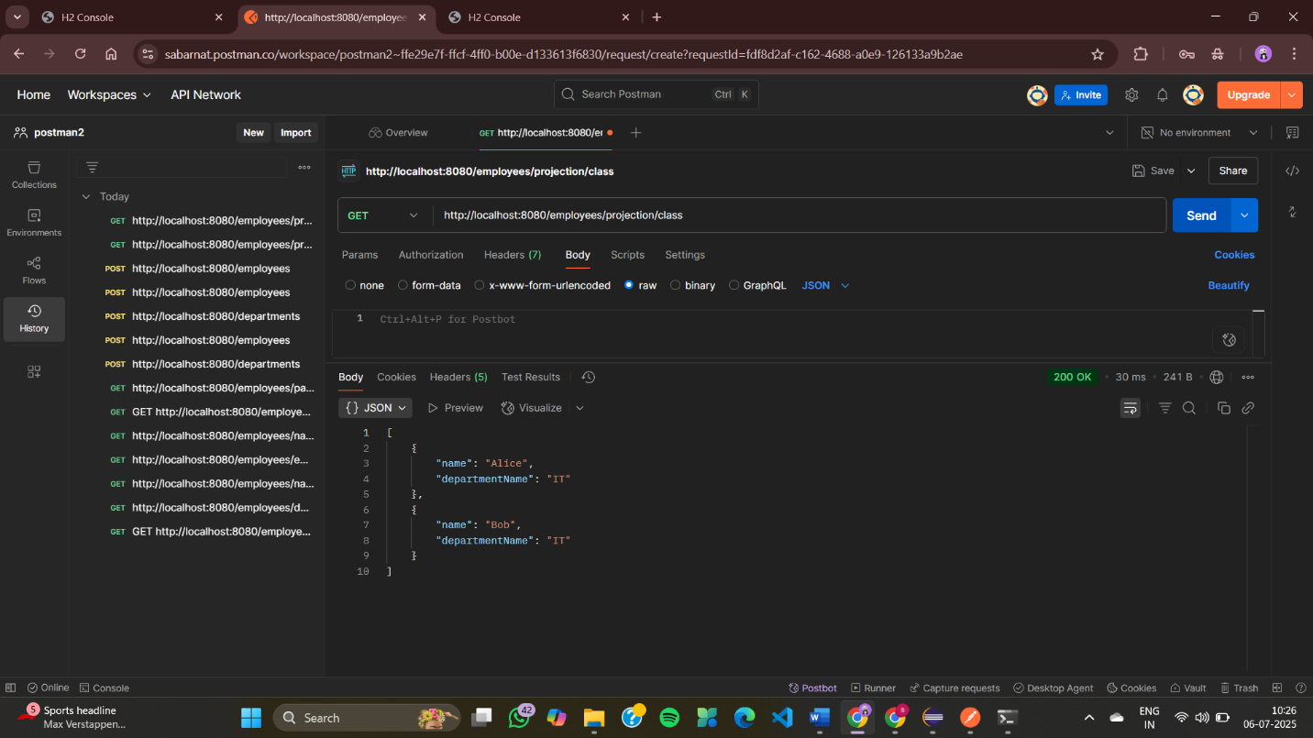
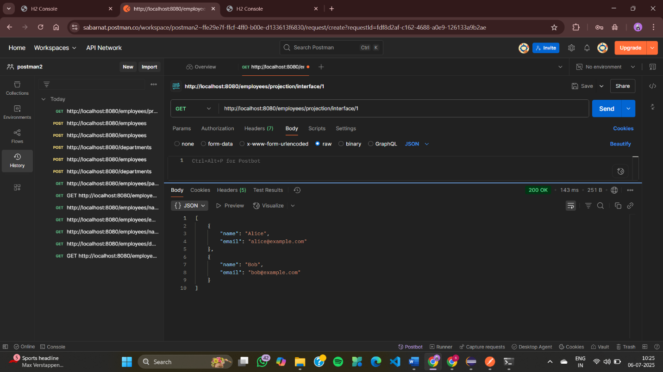
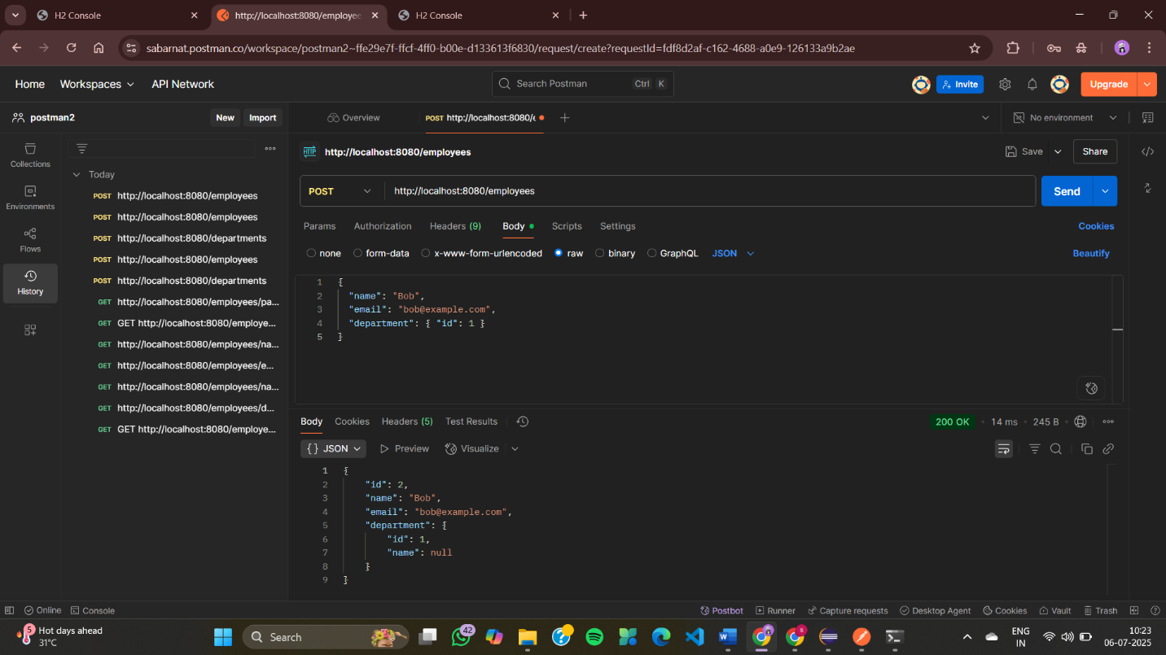
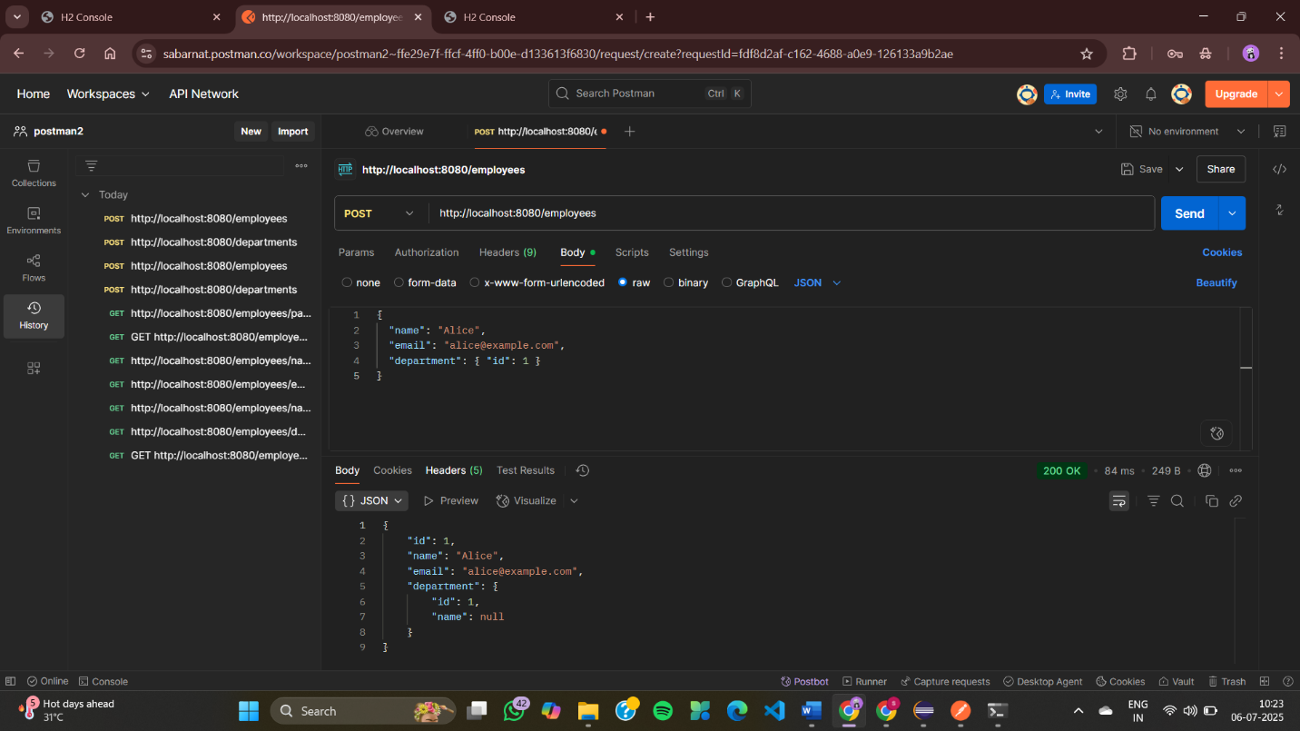

Exercise 9: Employee Management System - Customizing Data Source Configuration
EmployeeManagementSystemEx9Application.java
package com.example.EmployeeManagementSystem;

import org.springframework.boot.SpringApplication;
import org.springframework.boot.autoconfigure.SpringBootApplication;

@SpringBootApplication(scanBasePackages = "com.example")
public class EmployeeManagementSystemEx9Application {
public static void main(String[] args) {
SpringApplication.run(EmployeeManagementSystemEx9Application.class, args);
}
}
PrimaryDataSourceConfig.java
package com.example.config;
import jakarta.persistence.EntityManagerFactory;
import org.springframework.beans.factory.annotation.Qualifier;
import org.springframework.boot.autoconfigure.jdbc.DataSourceProperties;
import org.springframework.boot.context.properties.ConfigurationProperties;
import org.springframework.context.annotation.*;
import org.springframework.boot.orm.jpa.EntityManagerFactoryBuilder;
import org.springframework.data.jpa.repository.config.EnableJpaRepositories;
import org.springframework.jdbc.datasource.lookup.JndiDataSourceLookup;
import org.springframework.orm.jpa.JpaTransactionManager;
import org.springframework.orm.jpa.LocalContainerEntityManagerFactoryBean;
import org.springframework.orm.jpa.vendor.HibernateJpaVendorAdapter;
import org.springframework.transaction.PlatformTransactionManager;
import org.springframework.transaction.annotation.EnableTransactionManagement;
import javax.sql.DataSource;
@Configuration
@EnableTransactionManagement
@EnableJpaRepositories(
basePackages = "com.example.primary.repository",
entityManagerFactoryRef = "primaryEntityManagerFactory",
transactionManagerRef = "primaryTransactionManager"
)
public class PrimaryDataSourceConfig {

@Primary
@Bean
@ConfigurationProperties("spring.datasource")
public DataSourceProperties primaryDataSourceProperties() {
return new DataSourceProperties();
}

@Primary
@Bean
public DataSource primaryDataSource() {
return primaryDataSourceProperties().initializeDataSourceBuilder().build();
}

@Primary
@Bean
public LocalContainerEntityManagerFactoryBean primaryEntityManagerFactory(
EntityManagerFactoryBuilder builder) {
return builder
.dataSource(primaryDataSource())
.packages("com.example.primary.model")
.persistenceUnit("primary")
.build();
}

@Primary
@Bean
public PlatformTransactionManager primaryTransactionManager(
@Qualifier("primaryEntityManagerFactory") EntityManagerFactory emf) {
return new JpaTransactionManager(emf);
}
}
SecondaryDataSourceConfig.java
package com.example.config;
import jakarta.persistence.EntityManagerFactory;
import org.springframework.beans.factory.annotation.Qualifier;
import org.springframework.boot.autoconfigure.jdbc.DataSourceProperties;
import org.springframework.boot.context.properties.ConfigurationProperties;
import org.springframework.context.annotation.*;
import org.springframework.boot.orm.jpa.EntityManagerFactoryBuilder;
import org.springframework.data.jpa.repository.config.EnableJpaRepositories;
import org.springframework.orm.jpa.JpaTransactionManager;
import org.springframework.orm.jpa.LocalContainerEntityManagerFactoryBean;
import org.springframework.orm.jpa.vendor.HibernateJpaVendorAdapter;
import org.springframework.transaction.PlatformTransactionManager;
import org.springframework.transaction.annotation.EnableTransactionManagement;
import javax.sql.DataSource;
@Configuration
@EnableTransactionManagement
@EnableJpaRepositories(
basePackages = "com.example.secondary.repository",
entityManagerFactoryRef = "secondaryEntityManagerFactory",
transactionManagerRef = "secondaryTransactionManager"
)
public class SecondaryDataSourceConfig {

@Bean
@ConfigurationProperties("spring.secondary.datasource")
public DataSourceProperties secondaryDataSourceProperties() {
return new DataSourceProperties();
}

@Bean
public DataSource secondaryDataSource() {
return secondaryDataSourceProperties().initializeDataSourceBuilder().build();
}

@Bean
public LocalContainerEntityManagerFactoryBean secondaryEntityManagerFactory(
EntityManagerFactoryBuilder builder) {
return builder
.dataSource(secondaryDataSource())
.packages("com.example.secondary.model") // secondary entity package
.persistenceUnit("secondary")
.build();
}

@Bean
public PlatformTransactionManager secondaryTransactionManager(
@Qualifier("secondaryEntityManagerFactory") EntityManagerFactory emf) {
return new JpaTransactionManager(emf);
}
}
EmployeeController.java
package com.example.controller;
import com.example.primary.model.Employee;
import com.example.primary.repository.EmployeeRepository;
import com.example.secondary.model.AuditLog;
import com.example.secondary.repository.AuditLogRepository;
import org.springframework.beans.factory.annotation.Autowired;
import org.springframework.web.bind.annotation.*;
import java.time.LocalDateTime;
import java.util.List;
@RestController
@RequestMapping("/employees")
public class EmployeeController {

@Autowired
private EmployeeRepository employeeRepository;

@Autowired
private AuditLogRepository auditLogRepository;

@PostMapping
public Employee createEmployee(@RequestBody Employee employee) {
return employeeRepository.save(employee);
}

@GetMapping("/names")
public List<String> getEmployeeNames() {
return employeeRepository.findAll()
.stream()
.map(Employee::getName)
.toList();
}

@PostMapping("/log")
public String saveLog(@RequestParam String action) {
AuditLog log = new AuditLog();
log.setAction(action);
log.setTimestamp(LocalDateTime.now());
auditLogRepository.save(log);
return "Logged: " + action;
}
}
Department.java
package com.example.primary.model;
import jakarta.persistence.*;
@Entity
public class Department {
@Id
@GeneratedValue(strategy = GenerationType.IDENTITY)
private Long id;
private String name;
}

Employee.java
package com.example.primary.model;
import jakarta.persistence.*;
@Entity
public class Employee {
@Id
@GeneratedValue(strategy = GenerationType.IDENTITY)
private Long id;

private String name;
private String email;

@ManyToOne
private Department department;

public String getName() { return name; }
public void setName(String name) { this.name = name; }

public Long getId() { return id; }
public void setId(Long id) { this.id = id; }

public String getEmail() { return email; }
public void setEmail(String email) { this.email = email; }

public Department getDepartment() { return department; }
public void setDepartment(Department department) { this.department = department; }
}

DepartmentRepository.java
package com.example.primary.repository;
import com.example.primary.model.Department;
import org.springframework.data.jpa.repository.JpaRepository;
public interface DepartmentRepository extends JpaRepository<Department, Long> {
}
EmployeeRepository.java
package com.example.primary.repository;
import com.example.primary.model.Employee;
import org.springframework.data.jpa.repository.JpaRepository;
public interface EmployeeRepository extends JpaRepository<Employee, Long> {
}
AuditLog.java
package com.example.secondary.model;
import jakarta.persistence.*;
import java.time.LocalDateTime;
@Entity
public class AuditLog {
@Id
@GeneratedValue(strategy = GenerationType.IDENTITY)
private Long id;
private String action;
private LocalDateTime timestamp;
public Long getId() {
return id;
}
public String getAction() {
return action;
}
public LocalDateTime getTimestamp() {
return timestamp;
}
public void setId(Long id) {
this.id = id;
}
public void setAction(String action) {
this.action = action;
}
public void setTimestamp(LocalDateTime timestamp) {
this.timestamp = timestamp;
}
}
AuditLogRepository.java
package com.example.secondary.repository;
import com.example.secondary.model.AuditLog;
import org.springframework.data.jpa.repository.JpaRepository;
public interface AuditLogRepository extends JpaRepository<AuditLog, Long> {
}
application.properties
# PRIMARY DB (MySQL)
spring.datasource.url=jdbc:mysql://localhost:3306/employeedb
spring.datasource.username=root
spring.datasource.password=gopikA
spring.datasource.driver-class-name=com.mysql.cj.jdbc.Driver

# SECONDARY DB (H2)
spring.second-datasource.url=jdbc:h2:mem:auditdb
spring.second-datasource.driver-class-name=org.h2.Driver
spring.second-datasource.username=sa
spring.second-datasource.password=

# Enable H2 Console
spring.h2.console.enabled=true
spring.h2.console.path=/h2-console

# JPA settings
spring.jpa.hibernate.ddl-auto=update
EmployeeManagementSystemEx9ApplicationTests.java
package com.example.EmployeeManagementSystem;

import org.junit.jupiter.api.Test;
import org.springframework.boot.test.context.SpringBootTest;

@SpringBootTest
class EmployeeManagementSystemEx9ApplicationTests {

@Test
void contextLoads() {
}

}

OUTPUT
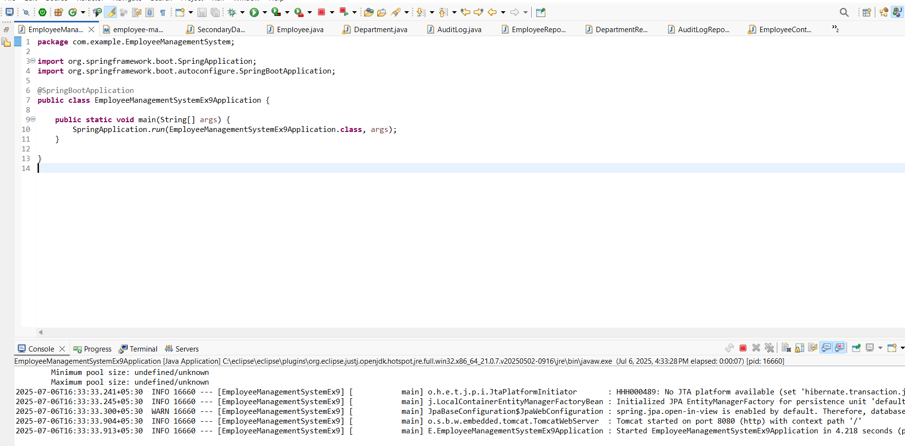
Exercise 10: Employee Management System - Hibernate-Specific Features
BatchController.java
package com.example.employeemanagement.controller;

import com.example.employeemanagement.entity.Employee;
import com.example.employeemanagement.service.EmployeeBatchService;
import org.springframework.beans.factory.annotation.Autowired;
import org.springframework.web.bind.annotation.*;

import java.util.ArrayList;
import java.util.List;

@RestController
@RequestMapping("/batch")
public class BatchController {

@Autowired
private EmployeeBatchService batchService;

@PostMapping("/employees/{count}")
public String createBulkEmployees(@PathVariable("count") int count) {
List<Employee> list = new ArrayList<>();
for (int i = 1; i <= count; i++) {
Employee e = new Employee();
e.setName("Emp-" + i);
e.setEmail("emp" + i + "@example.com");
e.setDepartment(i % 2 == 0 ? "IT" : "HR");
e.setAttributesJson("{"index":" + i + "}");
list.add(e);
}
batchService.saveEmployeesInBatch(list, 30);
return "Inserted " + count + " employees in batch";
}
}
Employee.java
package com.example.employeemanagement.entity;

import jakarta.persistence.*;
import lombok.*;
import org.hibernate.annotations.BatchSize;
import org.hibernate.annotations.DynamicUpdate;
import org.hibernate.annotations.GenericGenerator;
import org.hibernate.annotations.Type;

@Entity
@Data
@NoArgsConstructor
@AllArgsConstructor
@DynamicUpdate // Only changed columns in UPDATE
@BatchSize(size = 30) // Fetch batching for collections
public class Employee {

@Id
@GeneratedValue(strategy = GenerationType.IDENTITY)
private Long id;

private String name;

private String email;

@Column(columnDefinition = "varchar(255)")
private String department;

// Example JSON field stored as text; requires hibernate-types lib
@Type(org.hibernate.type.TextType.class)
@Column(columnDefinition = "clob")
private String attributesJson; // e.g. {"skill":"Java","level":5}
}
EmployeeRepository.java
package com.example.employeemanagement.repository;

import com.example.employeemanagement.entity.Employee;
import org.springframework.data.jpa.repository.JpaRepository;

public interface EmployeeRepository extends JpaRepository<Employee, Long> {
}
EmployeeBatchService.java
package com.example.employeemanagement.service;

import com.example.employeemanagement.entity.Employee;
import jakarta.persistence.EntityManager;
import jakarta.persistence.PersistenceContext;
import org.springframework.stereotype.Service;
import org.springframework.transaction.annotation.Transactional;

import java.util.List;

@Service
public class EmployeeBatchService {

@PersistenceContext
private EntityManager em;

/**
* Persist employees in batches for performance.
*/
@Transactional
public void saveEmployeesInBatch(List<Employee> employees, int batchSize) {
for (int i = 0; i < employees.size(); i++) {
em.persist(employees.get(i));
if (i % batchSize == 0 && i > 0) {
em.flush();
em.clear(); // free memory
}
}
}
}
EmployeeManagementSystemApplication.java
package com.example.employeemanagement;

import org.springframework.boot.SpringApplication;
import org.springframework.boot.autoconfigure.SpringBootApplication;

@SpringBootApplication
public class EmployeeManagementSystemApplication {
public static void main(String[] args) {
SpringApplication.run(EmployeeManagementSystemApplication.class, args);
}
}
application.properties
# DataSource (H2)
spring.datasource.url=jdbc:h2:mem:ems_db
spring.datasource.driverClassName=org.h2.Driver
spring.datasource.username=sa

# Hibernate Dialect & Batch settings
spring.jpa.properties.hibernate.dialect=org.hibernate.dialect.H2Dialect
spring.jpa.properties.hibernate.jdbc.batch_size=30
spring.jpa.properties.hibernate.order_inserts=true
spring.jpa.properties.hibernate.order_updates=true
spring.jpa.properties.hibernate.batch_versioned_data=true
spring.jpa.properties.hibernate.generate_statistics=true

spring.jpa.hibernate.ddl-auto=update
spring.jpa.show-sql=true

# Enable H2 console
spring.h2.console.enabled=true
OUTPUT
